Hilton Toronto-Markham   
Hotel Management System

Database class project, academic year 2023/2024

|  |  |  |  |  |
| --- | --- | --- | --- | --- |
| Student Name in English | Student Name in Arabic | Student ID | Section time as shown in Zajel | Work percentage |
| Hamza Younes | حمزة يونس |  | 8:00am - 9:30am | 100% |
|  |  |  |  |  |
|  |  |  |  |  |

---------------------------------------------This section is intended for the Instructor---------------------------------------

|  |  |
| --- | --- |
| **Topic** | **Mark** |
| Project Requirements and Modeling |  |
| Correctness of Database mapping |  |
| Functional Dependency and Normalization |  |
| Project Tools |  |
| Project Discussion |  |
| Project Completeness |  |
| Project Output Results or reporting (JasperReport, charts, graphs, etc.) |  |
| Project Administration and Management |  |
| Project Report |  |
| Project Idea |  |
| Project Complexity |  |
| Team work |  |
|  |  |
|  |  |
|  |  |

# Abstract

*This project revolves around creating a fully functional database system for the Toronto-Markham Hilton Hotel using PostgreSQL and Java (AWT & Swing) for the interface. The Database holds six tables including “Staff”, “Guests”, “Bookings”, “Rooms”, “RoomService” and “Services”.*

*The “Staff” table holds the personal information such as ID, Name, Address, Phone number and email, log-in details (password), salary and position of each staff member. The “Guests” table is structured in a similar manner where it holds each guest’s personal information (ID, name, nationality, address, phone number and email address) alongside their log-in details (password).*

*The “Rooms” table manages the rooms in the hotel while the “Bookings” table manages the booking of rooms. The “Services” table manages the services available in the hotel while the “RoomService” table manages the booking of those services by the guests and assigns the adequate staff to preform those services.*

*Apart from the database creation, this project also involves building a user-friendly graphical user interface using Java (AWT & Swing). This allows both staff members and guests to easily manage and manipulate the data stored in the database.*

*Overall, this system aims to streamline the workflow at the Toronto-Markham Hilton Hotel increasing efficiency and ensuring the highest standards of hospitality through proper data management and easy accessibility.*

Table of Contents

Abstract 2

Introduction 5

Project Requirements 6

• Room Management 6

• Guests Management 6

• Booking Management 6

• Staff Management 6

• Service Management 7

• Room Service Management 7

Functional Dependency & BCNF Check 8

• Rooms Table 8

• Guests Table 8

• Bookings Table 8

• Staff Table 9

• Service Table 9

• Room Service Table 9

ERD/UML Diagram 10

Tools Used in the Project 11

Program GUI in depth 11

Main Log-in Menu 11

Guest GUI 12

• Guest log-in page 12

• Guest Sign-Up page 12

• Guest Main Page 13

• Guest’s My Info Page 13

• Guest’s My Bookings Page 14

• Guest’s My Booked Room Services 14

• Guest Book Page 15

• Guest Book Room 15

• Guest Book Service 16

Staff GUI 17

• Staff Log-in Page 17

• Staff Main Page 17

• Staff’s My Info Page 18

• Staff’s Assigned Services 18

Admin GUI 19

• Admin Log-in Page 19

• Admin Main Page 19

• All Staff Page 20

• All Guests Page 22

• All Bookings Page 24

• All Booked Room Services Page 26

• All Rooms Page 30

Jasper Reports 32

• Admin All Staff Report 32

• Admin All Bookings Report 32

• Admin All Guests Report 33

• Admin All Room Services Report 33

• Admin All Services Report 34

• Admin All Rooms Report 34

Conclusion 35

References 35

# Introduction

*During my stay at the Toronto-Markham Hilton Hotel, I noticed a lack of technology when it came to managing the hotel’s Services. Staff relied on a front-desk system which required guests to book services by contacting the front desk. So, I decided to use this this project as an opportunity to explore the avenues of how hotels could utilize database Systems and digitalize data handling by eliminating paperwork and its associated inconveniences using Java (AWT & Swing) and PostgreSQL.*

*The South and West Views from the Room I stayed in:  
  
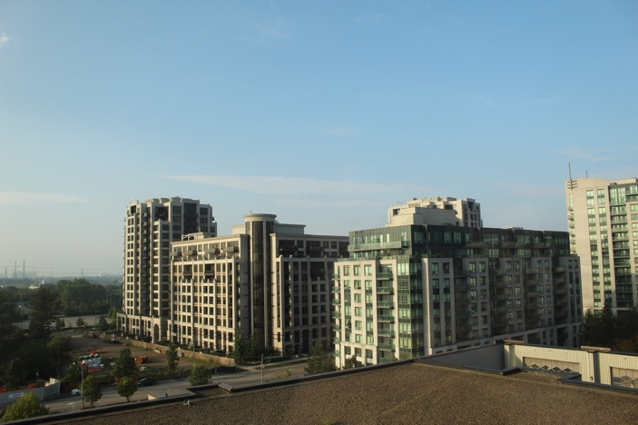*

# Project Requirements

* Room Management

*The Rooms table serves as a repository of information regarding the various accommodations offered by the hotel. Each room is uniquely identified by a RoomID (Room Number). The table includes attributes such as Type, which specifies the room category (Single, Double, Suite), Rate, indicating the price per night for the room, and Availability, which denotes whether the room is booked or free to be assigned to a booking.*

* Guests Management

*The Guests table stores the governmental ID of the guest in GuestID which is also used as an identifier for logging in, facilitating efficient data management. The table includes attributes like Name, Nationality, Address, PhoneNumber, and Email, providing a comprehensive profile of each guest. Additionally, GuestPassword is included for authentication purposes when logging in.*

* Booking Management

*Central to the hotel's reservation system, the Bookings table maintains records of guest bookings. Each booking is assigned a unique BookingID for easy reference. The table establishes relationships with the Guest and Room tables through GuestID and RoomID, respectively, associating each booking with the corresponding guest and room. CheckInDate and CheckOutDate denote the dates of guest arrival and departure, facilitating efficient scheduling and occupancy management.*

* Staff Management

*Essential for staff management, the Staff table contains pertinent information about the hotel's workforce. The hotel Manager (“Admin” positioned staff) provides the staff with unique ID numbers which are stored as StaffID. Attributes such as Name, Position, Salary, Address, PhoneNumber, and Email provide a comprehensive profile of each staff member. Additionally, StaffPassword ensures secure access to staff accounts, safeguarding sensitive information and system integrity.*

* Service Management

*The Service table stores the various amenities and services offered by the hotel. Each service is assigned a unique ServiceID for reference. Attributes include Name, Description, and Price, providing detailed information about each service's offerings and associated costs. This table serves as a resource for guests to explore available services and make informed choices during their stay.*

* Room Service Management

*Facilitating guest requests and service fulfillment, the RoomService table tracks room service transactions. Each request is assigned a unique RoomServiceID, enabling efficient tracking and management. The table establishes relationships with the Booking, Service, Staff, Room, and Guest tables, ensuring accurate recording and allocation of services. Attributes such as Quantity and Status provide additional details about each service request and its processing status.*

*Within this system, users have varying levels of access. Admins hold complete control over the database, with the power to add, edit, or remove data from any table. Guests have the ability to book and cancel services and bookings independently; however, any modifications to existing reservations require contacting the front desk. Staff are restricted to updating the status of their assigned room service orders ("Delivered" or "Not Delivered"). Account creation follows a hierarchical structure: guests can sign up, while staff accounts are created exclusively by admins, who also determine positions ("Admin" or "Staff"). Both staff and admins use a sign-in process rather than a sign-up option.*

*The functional requirements are simplified in the table below:*

|  |  |  |  |  |  |  |
| --- | --- | --- | --- | --- | --- | --- |
| Permissions | Book  Rooms & Services | Edit/Update  Room Bookings | Edit/Update Room Services | Cancel Bookings | Cancel Services | Create Accounts |
| Staff w Admin |  |  |  |  |  |  |
| Guest |  |  |  |  |  |  |
| Staff |  |  | Only Service Status |  |  |  |

# Functional Dependency & BCNF Check

* Rooms Table

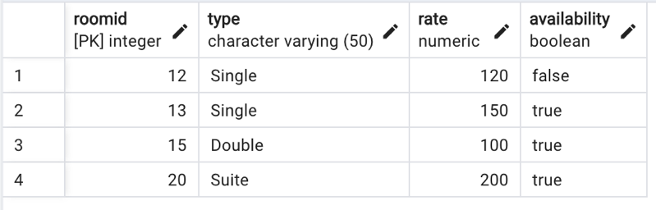  
*1NF has a primary key that uniquely identifies each row*

* Guests Table

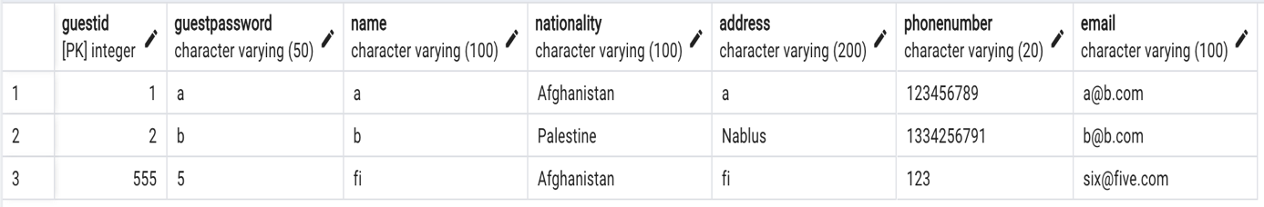  
*1NF has a primary key that uniquely identifies each row*

* Bookings Table

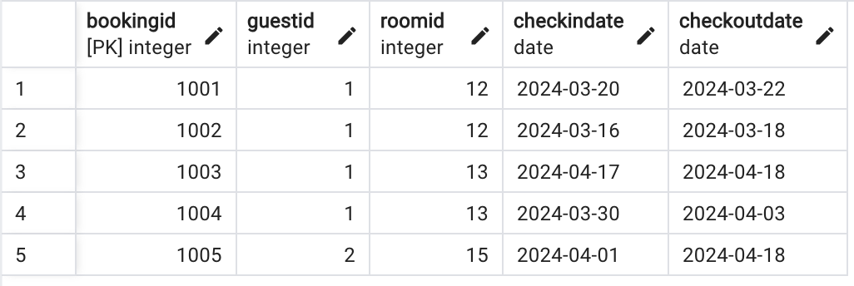  
*1NF has a primary key that uniquely identifies each row*

* Staff Table

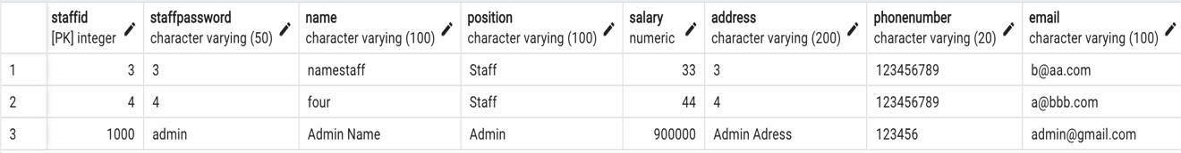  
*1NF has a primary key that uniquely identifies each row*

* Service Table

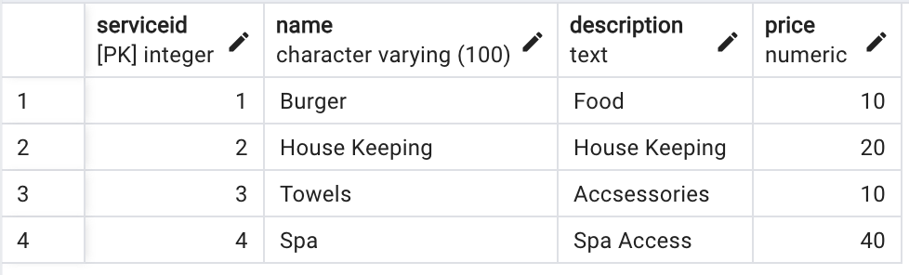  
*1NF has a primary key that uniquely identifies each row*

* Room Service Table

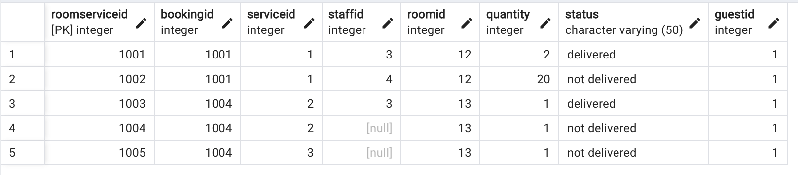  
*1NF has a primary key that uniquely identifies each row*

*Since all tables are already in 1NF and there are no partial or transitive dependencies present. Each table is in both 2NF and 3NF because there are no composite or transitive dependencies. Therefore, all tables in the database are BCNF.*

# ERD/UML Diagram

*ERD Generated using pgAdmin4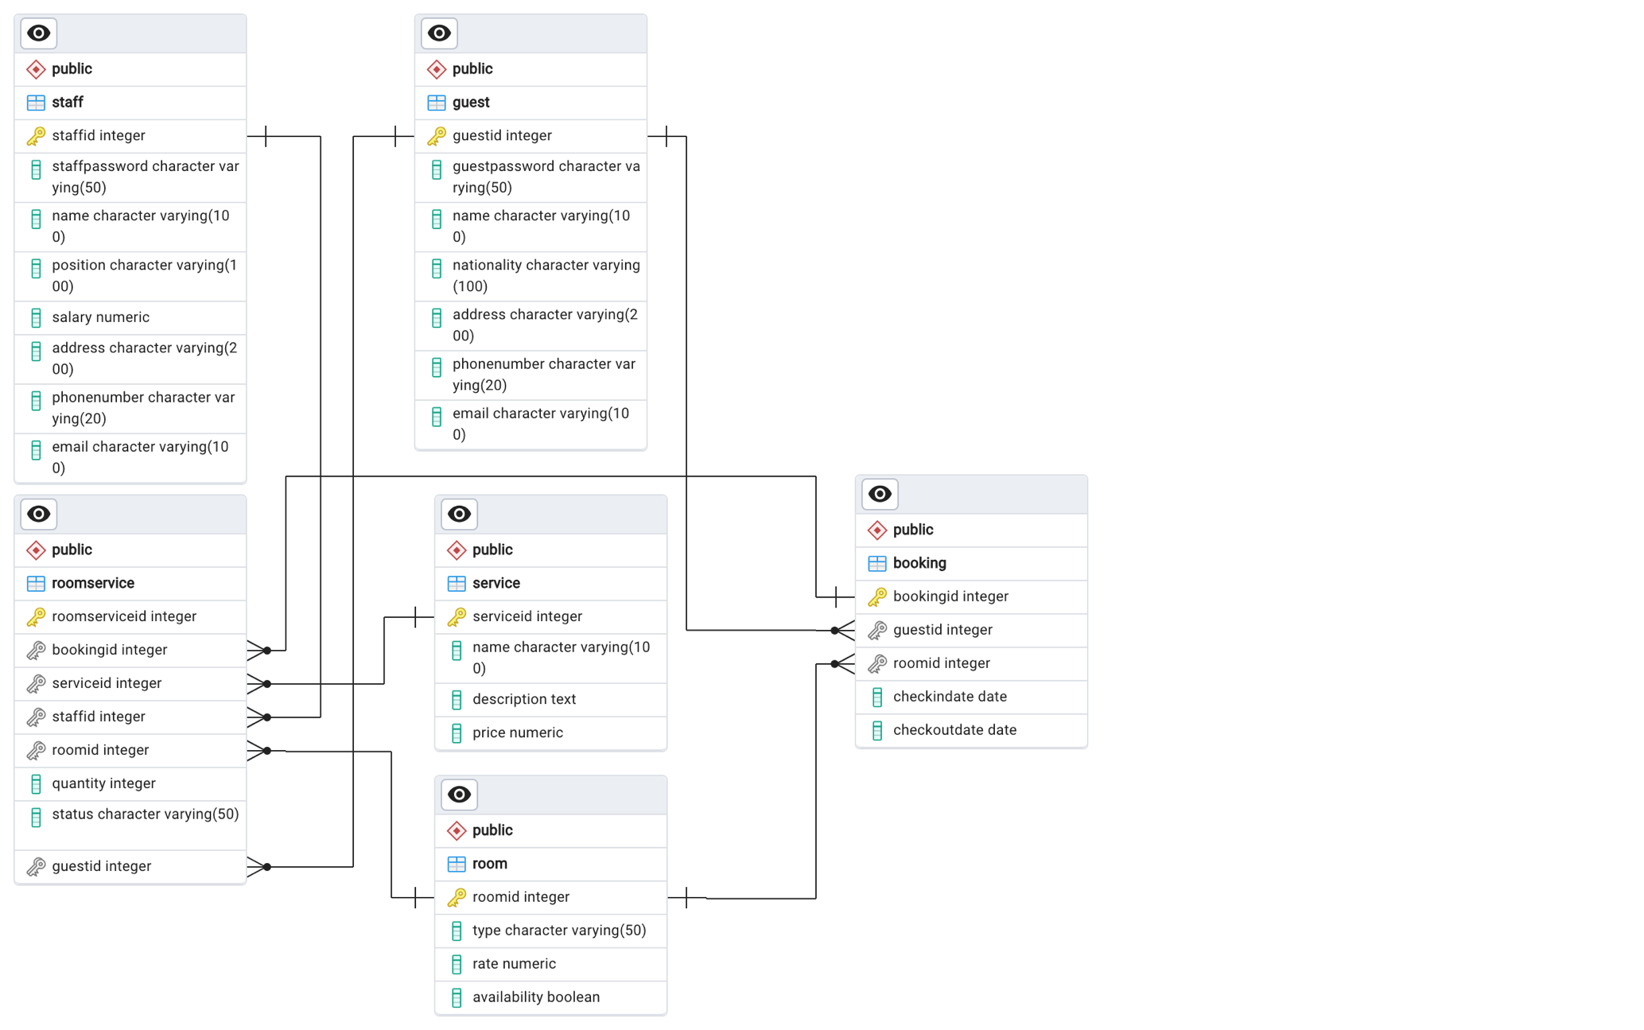 UML Designed in Draw.io  
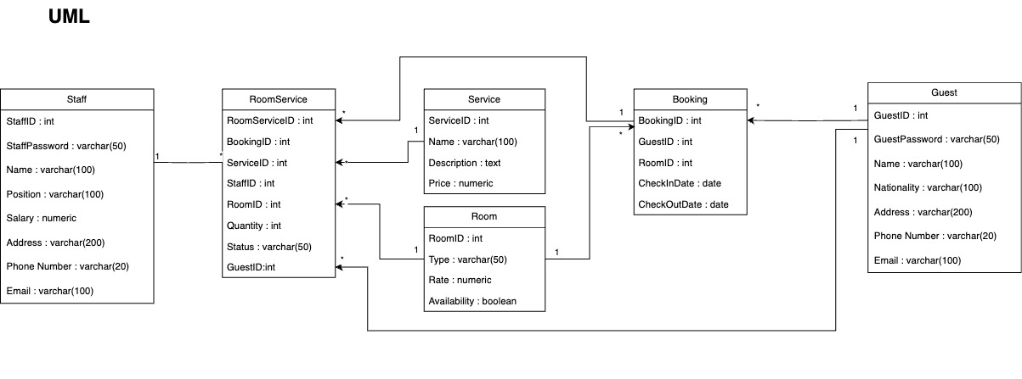*

# Tools Used in the Project

* *IntelliJ IDEA CE 2023.2*
* *Apache NetBeans IDE 19*
* *pgAdmin4 (Version 8.2)*
* *Jaspersoft Studio 9.0.0 Pro*
* *Adobe Photoshop 2020 (21.2.0 Release)*
* *Draw.io*
* *Microsoft Word 2021 (Version 16.83)*

# Program GUI in depth

## Main Log-in Menu

*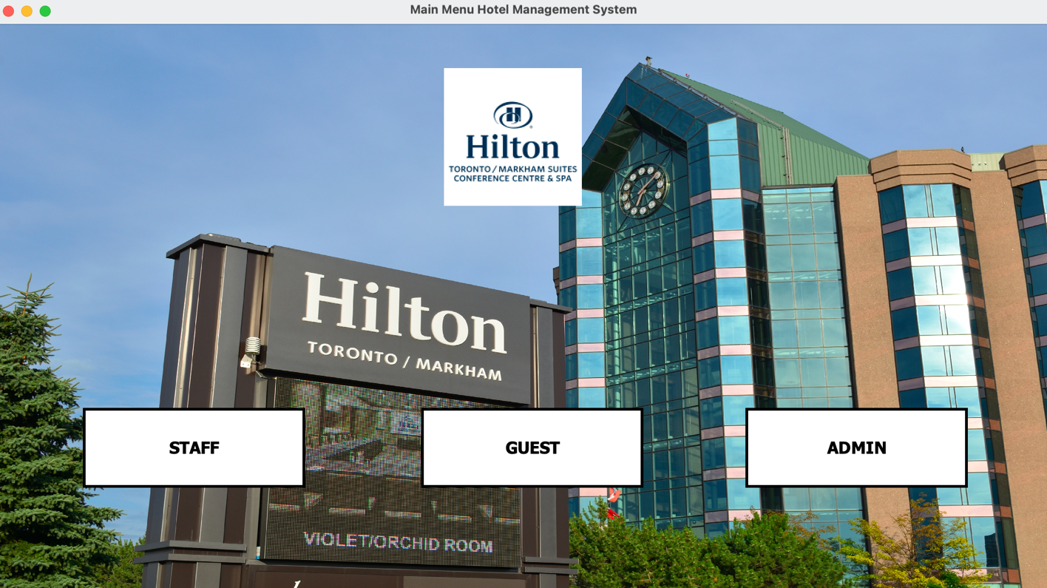  
Here users can choose what account type they’d like to log-in as  
“Staff” Positioned Staff can log-in using the Staff page, Guests can log-in from the Guest page and “Admin” positioned Staff can log-in from the Admin page*

## Guest GUI

* Guest log-in page

*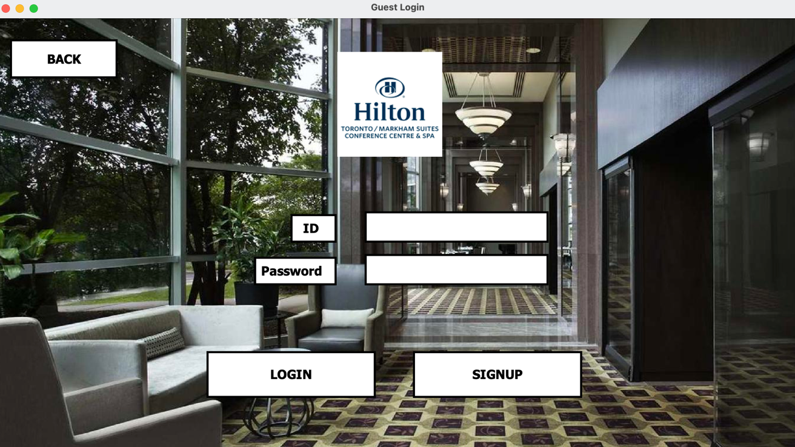  
Guests can log-in with the credentials they used to sign-up for their account in database after signing-in the guest is redirected to the Guest’s main page*

* Guest Sign-Up page

*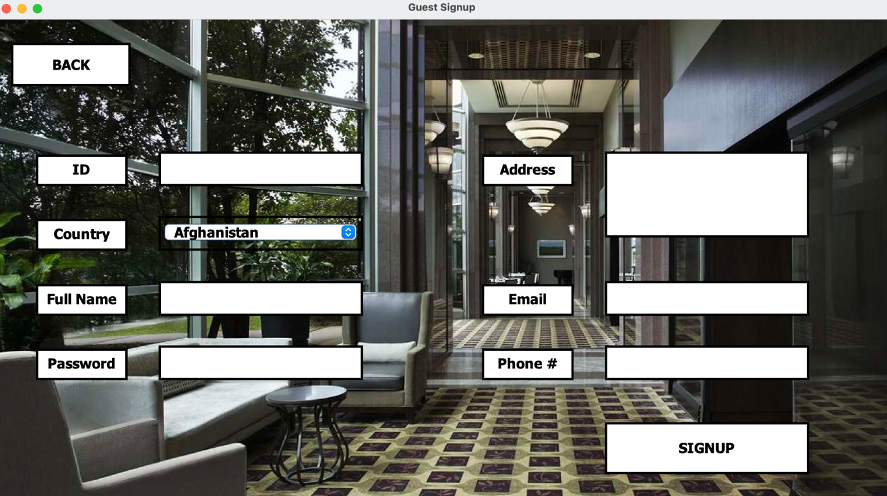  
After signing-up users are redirected to the log-in page to log-in with the credentials they signed-up with*

* Guest Main Page

*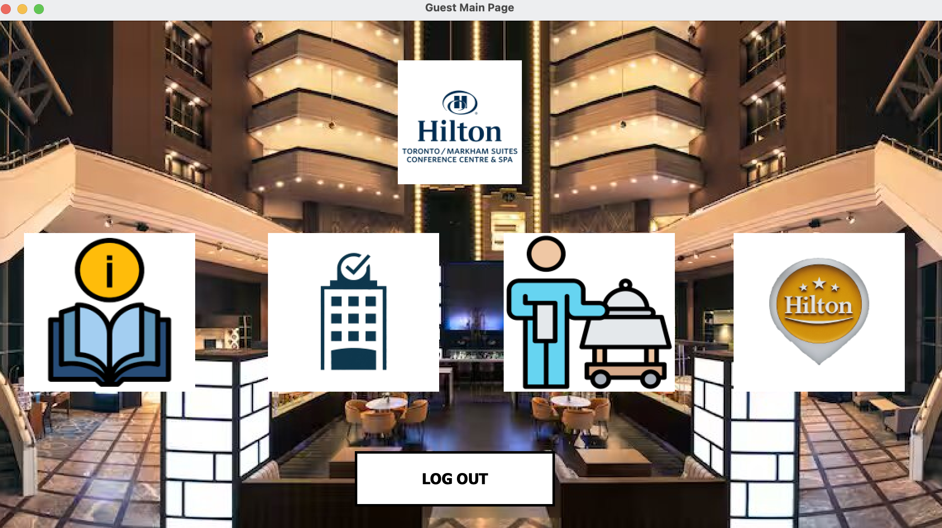  
On this page there are 5 buttons that lead to 5 different Pages. “My Info” which leads to the Guest’s (logged-in user) Info Page, “My Bookings” which leads to the Guest’s Bookings, “My Booked Room Services” which leads to the Guest’s booked room services and “Book” which leads to the Booking options page. The log-out button logs the guest out and redirects the user to the Guest log-in page*

* Guest’s My Info Page

*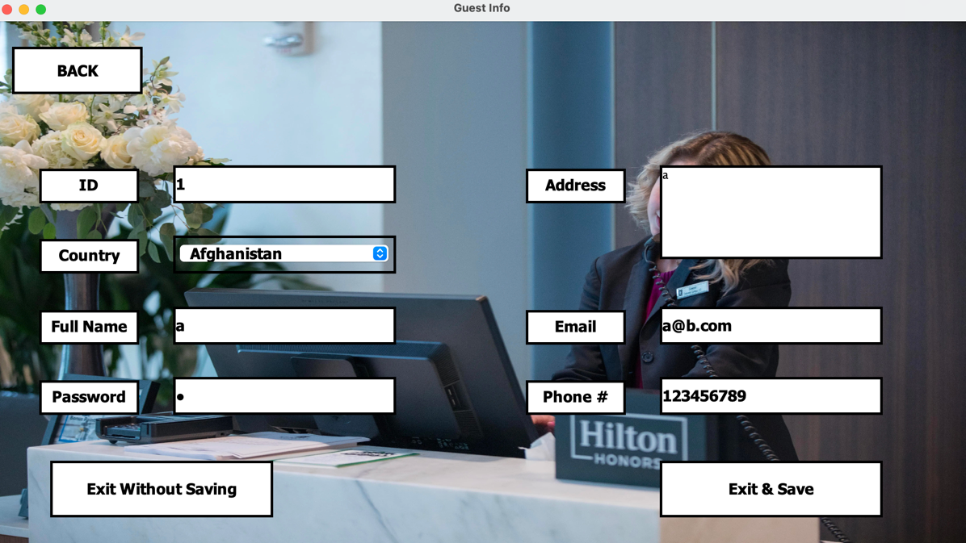  
In this page the guest’s (logged-in user) info appears in the textboxes where they can view their personal information and edit it. If they’d like to save the changes they’ve made they can press “Exit & Save” if not then “Exit Without Saving”.*

* Guest’s My Bookings Page

*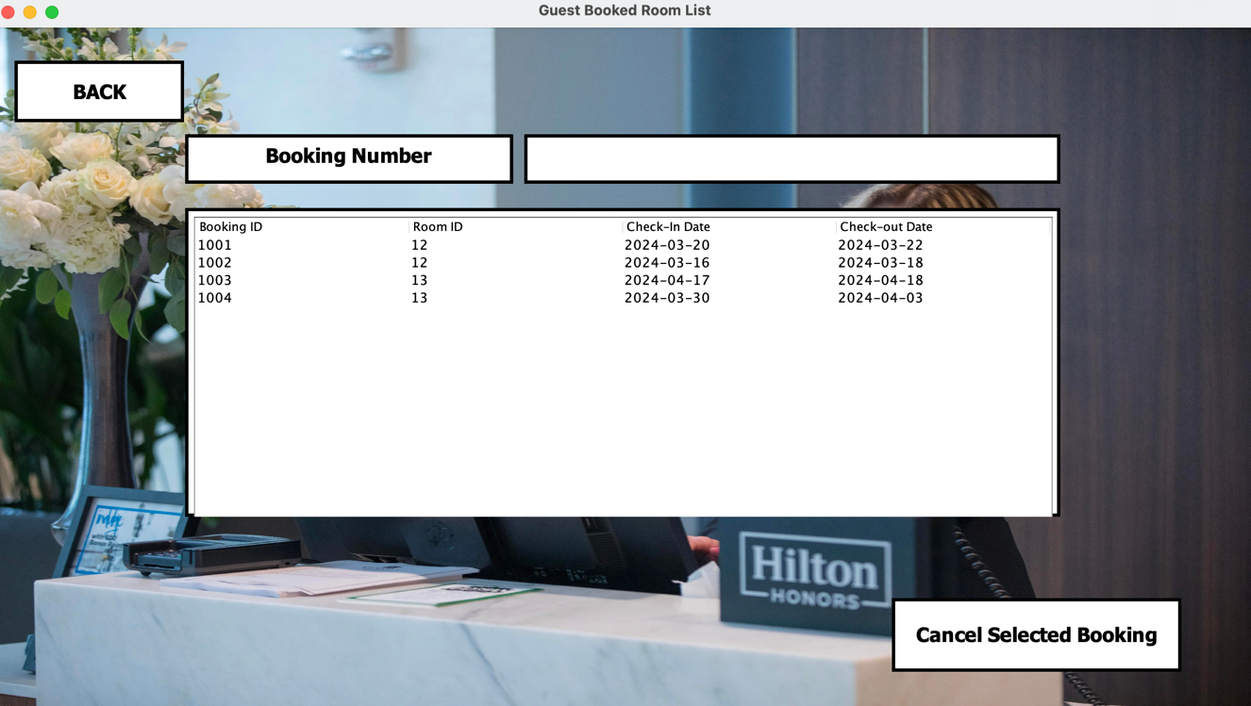  
In this page the guest (logged-in user) can view their bookings and cancel any booking as long as the check-in date hasn’t exceeded the current day’s date by entering the booking number and pressing “cancel selected booking”.*

* Guest’s My Booked Room Services

*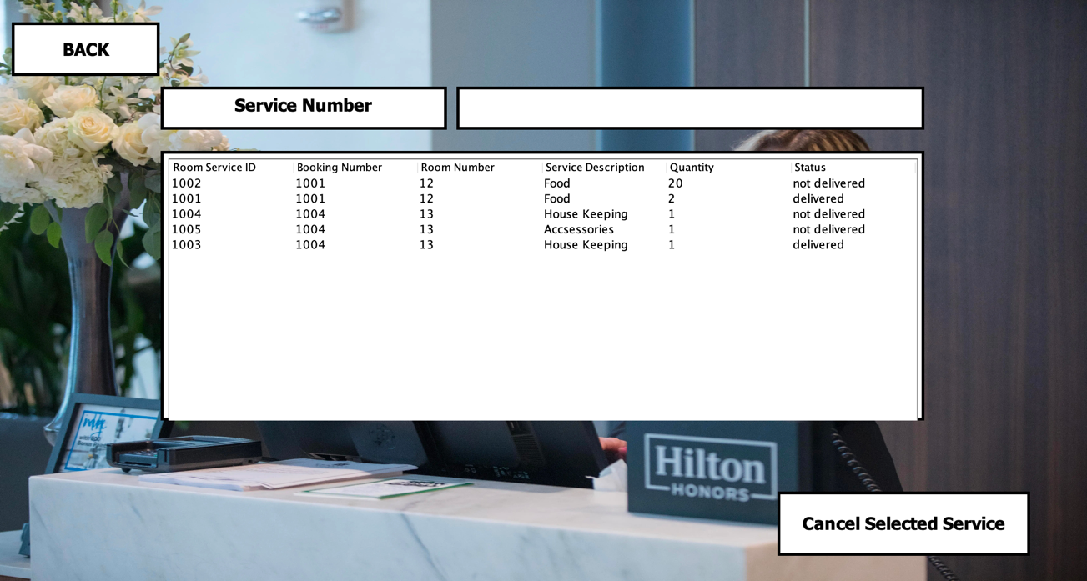  
In this page the guest (logged-in user) can view their booked room services and cancel any of them as long as their status isn’t “Delivered” by entering the Room Service number and pressing “cancel selected service”.*

* Guest Book Page

*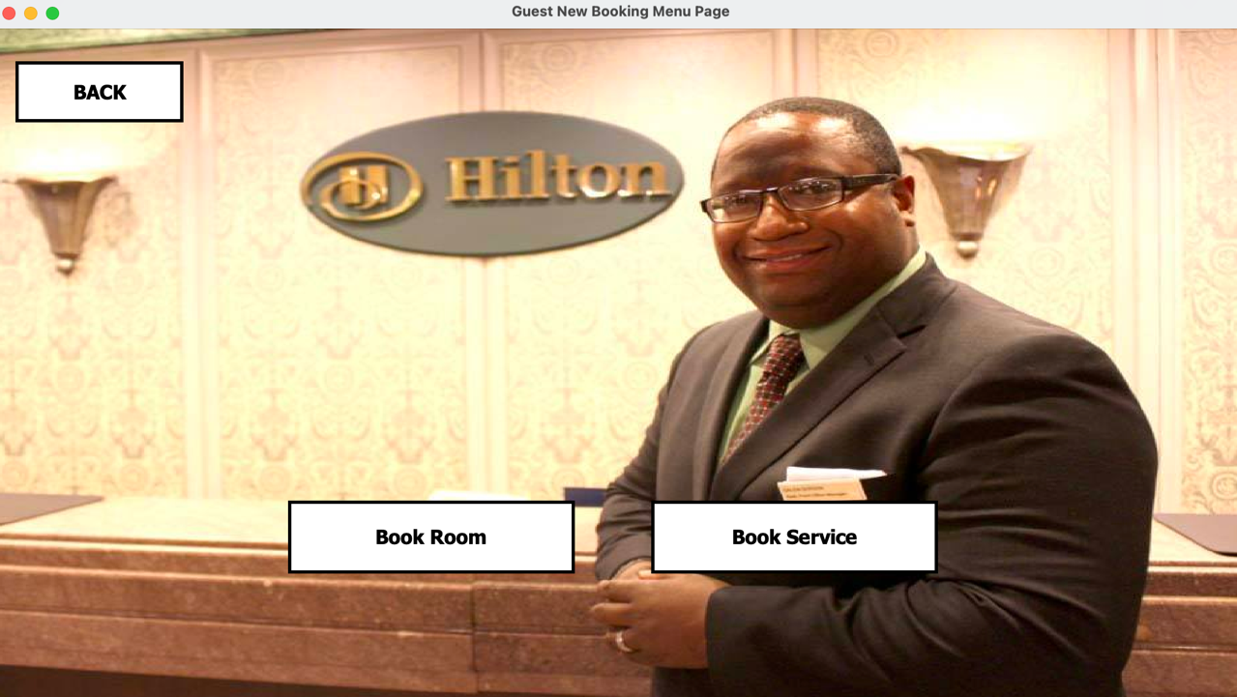  
On this page guests can choose what they’d like to book (Room or Room Service).*

* Guest Book Room

*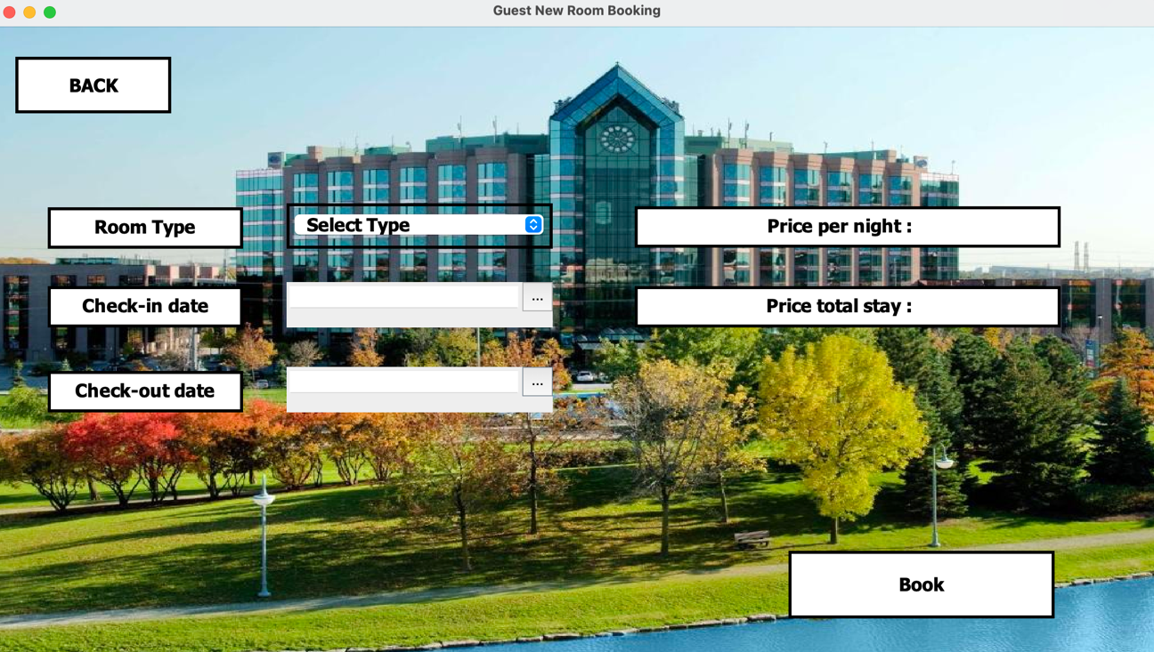  
On this page Guests can book a room (create a new Booking) by selecting the room type from the drop-down menu which will update the price per night label, the check-in and out dates using the pop-up calendar. Based on the Dates selected the total stay label price will update based on how many days the stay will last. Guests can book an available room on a date after the current day’s date.*

* Guest Book Service

*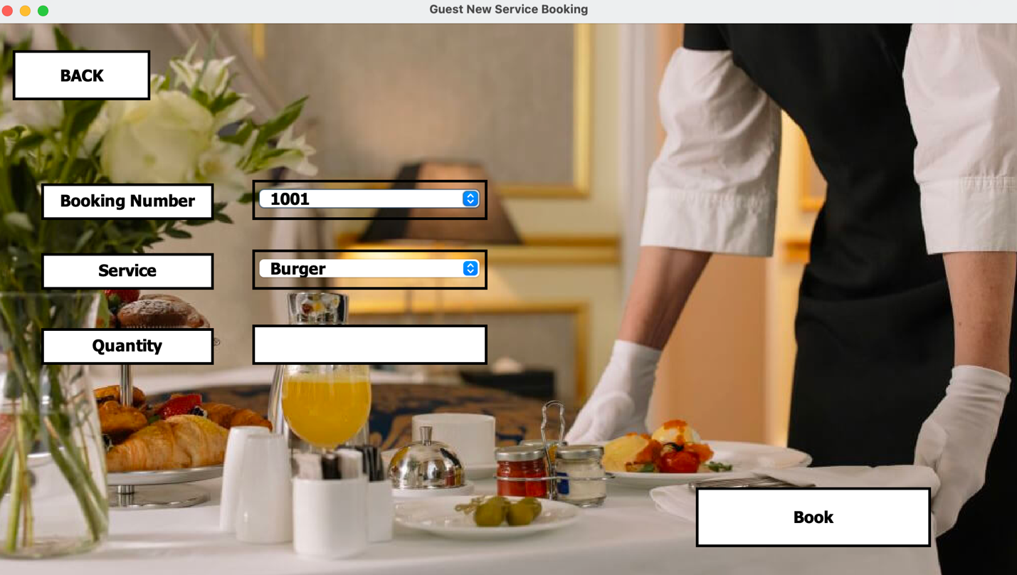  
On this page Guests can book a room service for their booking. The guests’ (logged-in user) bookings will appear in a drop-down menu where the guest can select the booking they’d like to book the service for. The services offered by the hotel will appear in a drop-down menu where the guest can select the service they’d like. In the text field below the guest can determine the quantity of the service they desire.*

## Staff GUI

* Staff Log-in Page

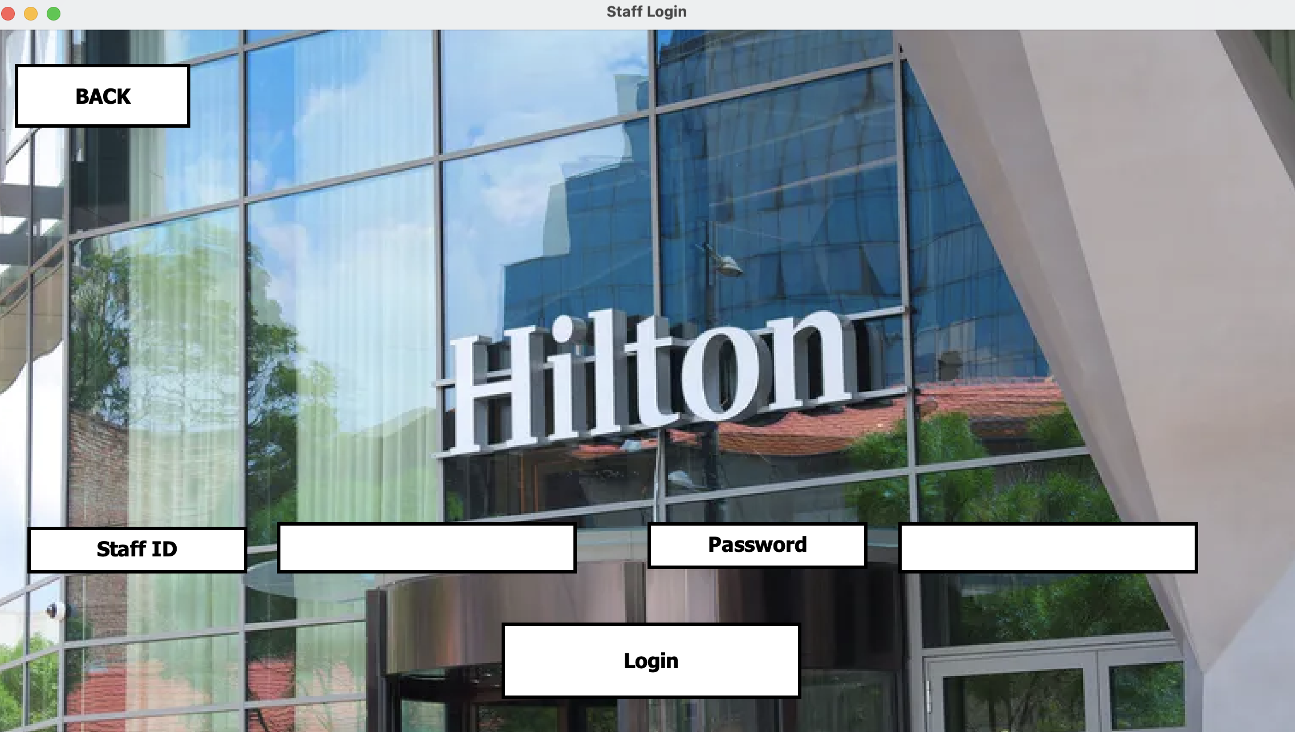

* Staff Main Page

*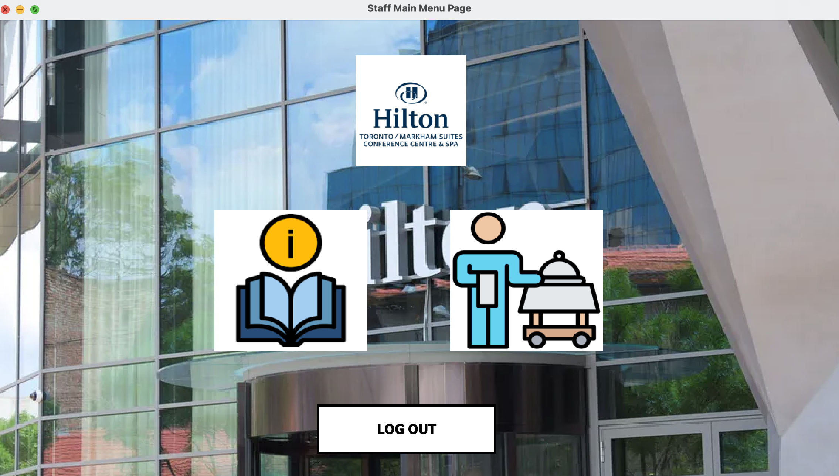  
On this page there are three buttons “My Info” which leads to the Staff’s (logged-in user) info page, “My Services” which leads to the Staff’s assigned services and the “Log-out” button which logs the user out and redirects them to the Staff Log-in page*

* Staff’s My Info Page

*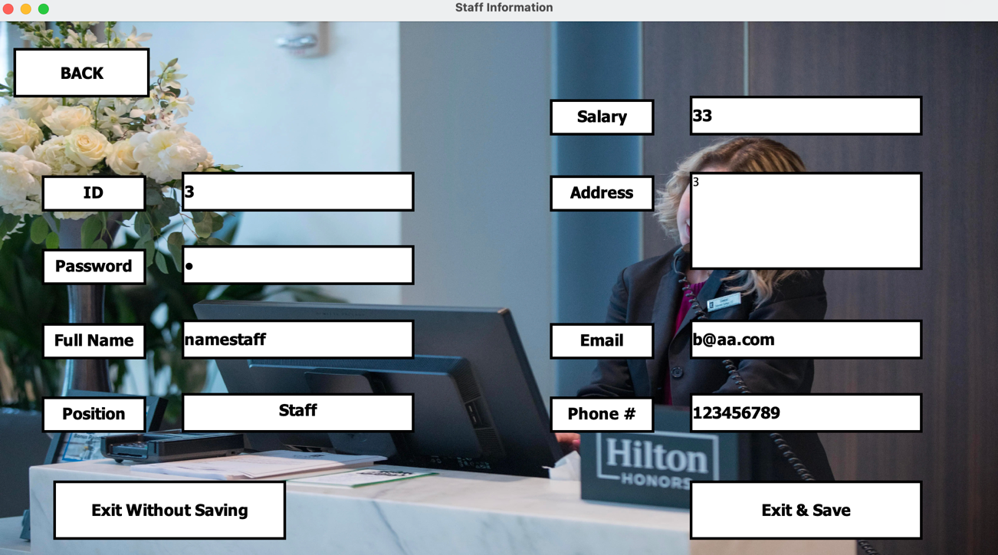  
In this page the guest’s info appears in the textboxes where they can view their personal information and edit it (Except their position) if they’d like to save the changes they’ve made they can press “Exit & Save” if not then “Exit Without Saving”.*

* Staff’s Assigned Services

*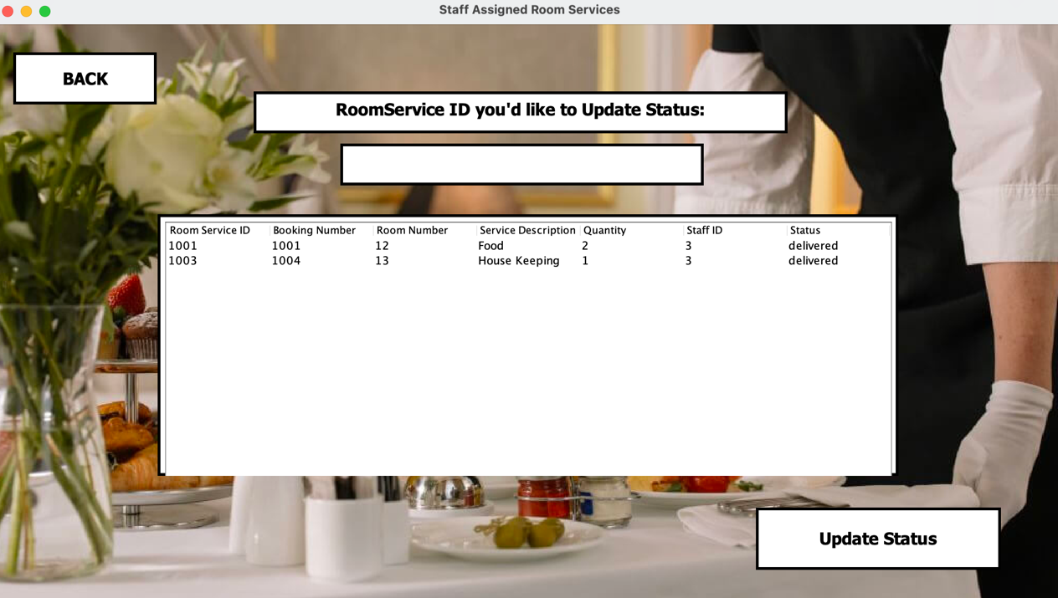  
In this page the logged-in user (Staff) can see their assigned Room Service where they can update the Room Service’s Status to “Delivered” upon completion by typing in the Room Service ID they’d like to update its status and clicking on “Update Status”.*

## Admin GUI

* Admin Log-in Page

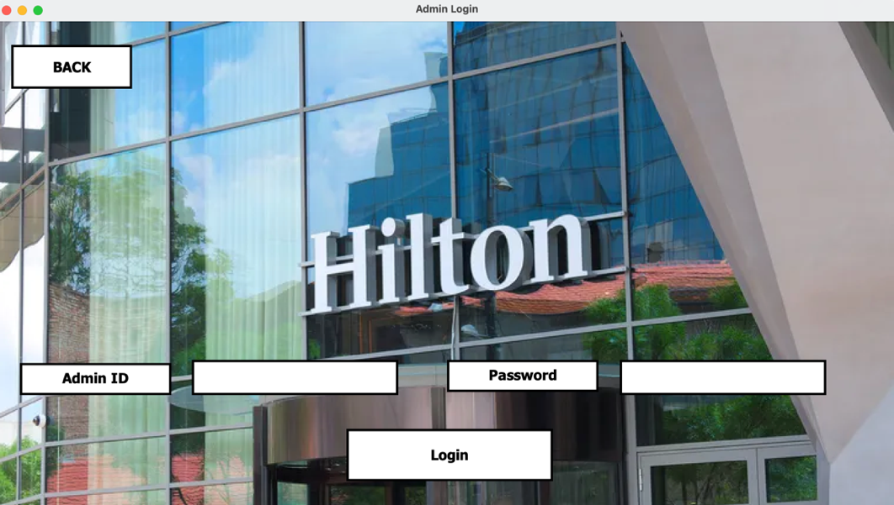

* Admin Main Page

*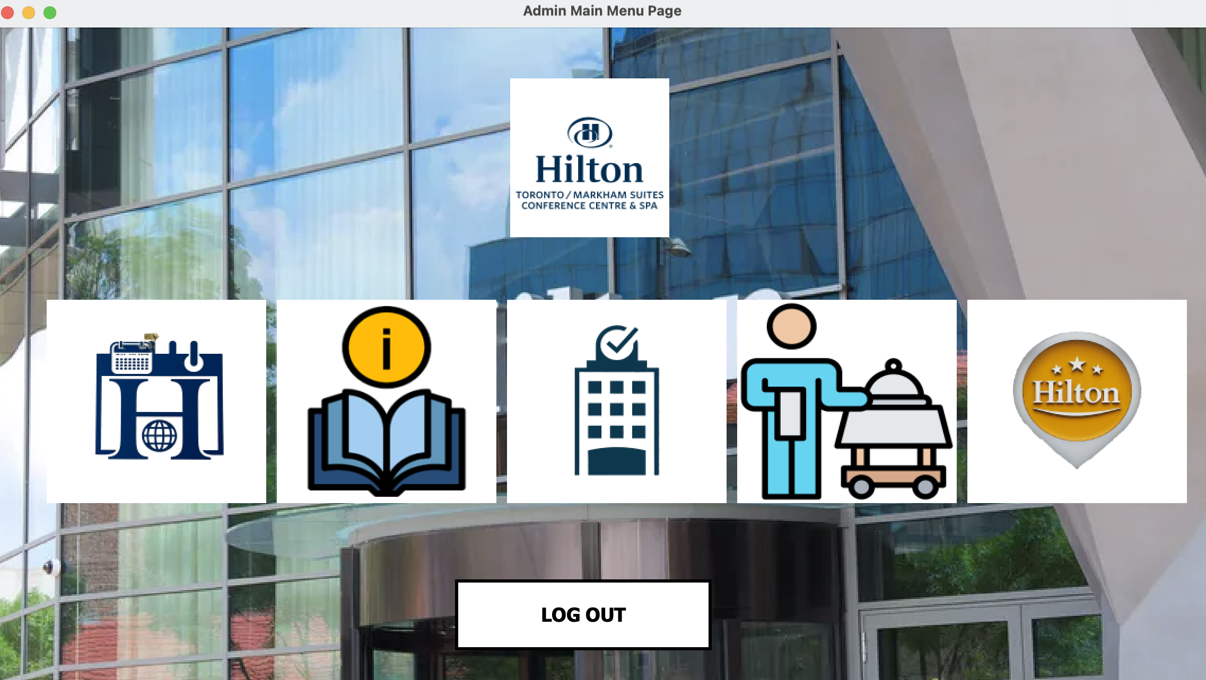  
On this page there are 6 buttons that lead to 6 different Pages. “All Staff” which leads to the All Staff Page, “All Guests” which leads to the All Guests page, “All Bookings” which leads to the All bookings page, “All Booked Room Services” which leads to the All Booked Room Services page, “All Rooms” which leads to the All Rooms Page and The log-out button which logs the user out and redirects them to the Admin log-in page.*

* All Staff Page

*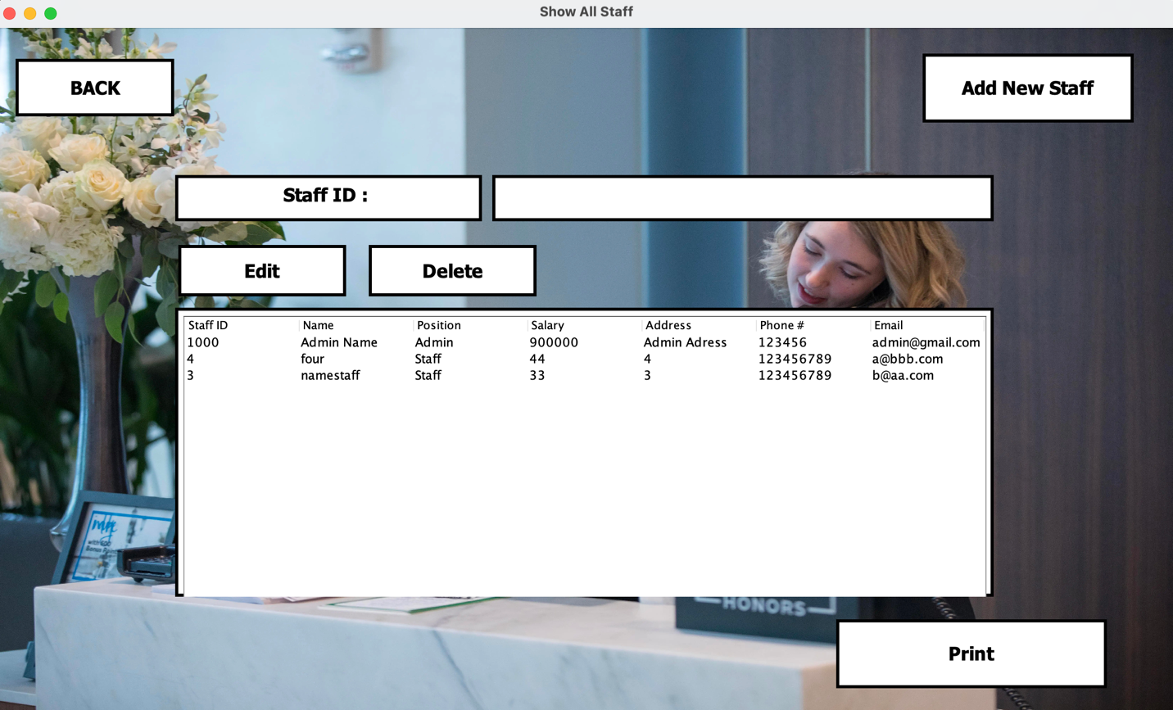  
In this page Admin can delete any staff by entering the ID number of the staff they’d like to delete and clicking the “Delete” button. Admin can edit any staff’s info by entering their ID number and clicking on edit which will show the following page which is structured in a similar manner to the “Staff Info Page” with the only exception being is that the admin can edit any field  
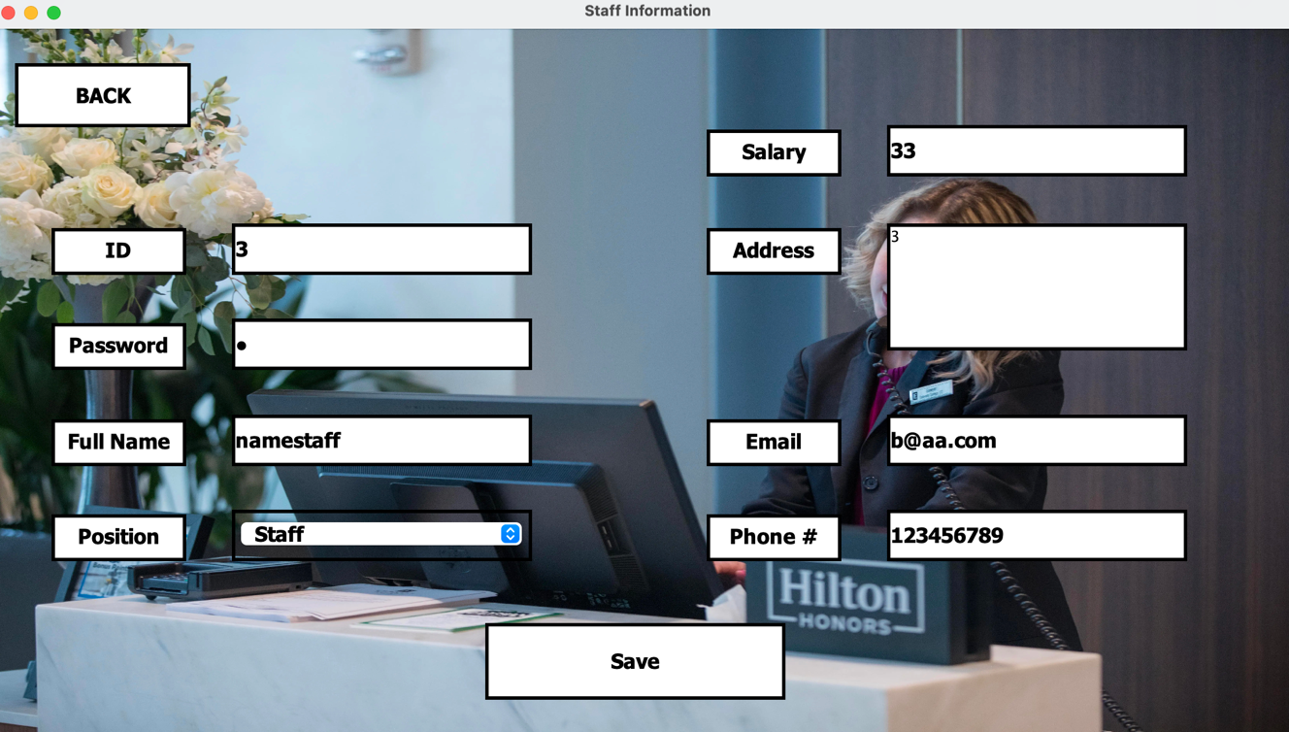  
Admin can Add Staff by clicking the “Add staff” button which will show the following page where admin can create a new staff  
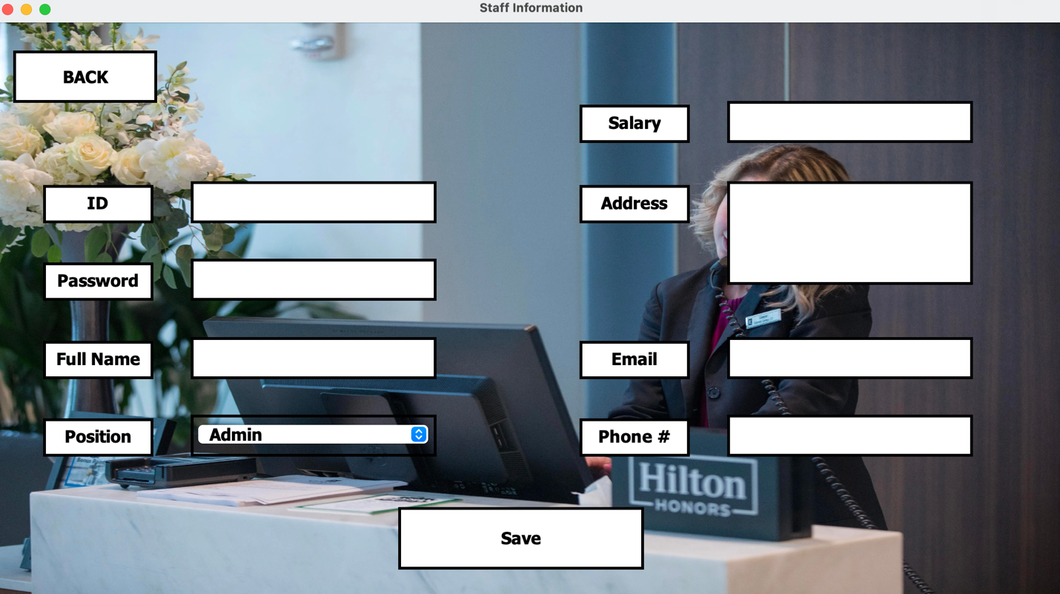  
Admin can Create a Jasper Report of All Staff By clicking the “Print” Button which will show a jasper report window and create a .pdf file of the report  
  
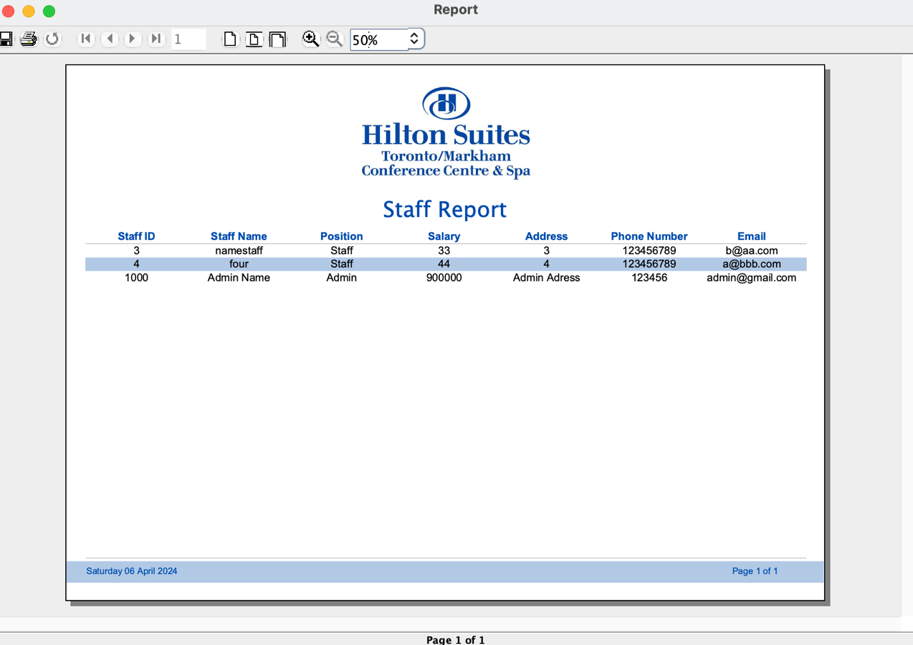*

* All Guests Page

*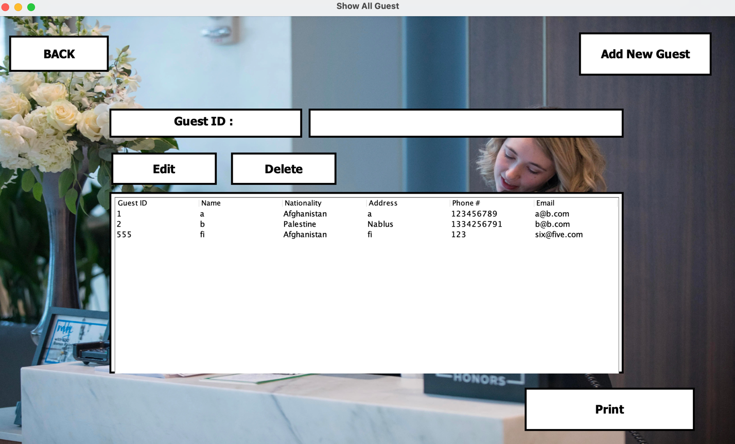  
In this page Admin can delete any Guest by entering the ID number of the Guest they’d like to delete and clicking the “Delete” button. Admin can edit any Guest’s info by entering their ID number and clicking on edit which will show the following page which is structured in a similar manner to the “Guest Sign-up Page”  
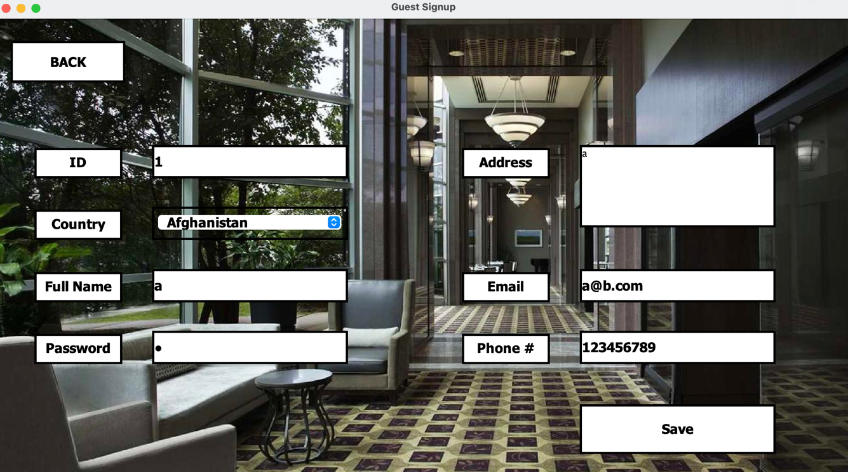  
  
Admin can Add Guests by clicking the “Add Guest” button which will show the following page where admin can create a new guest  
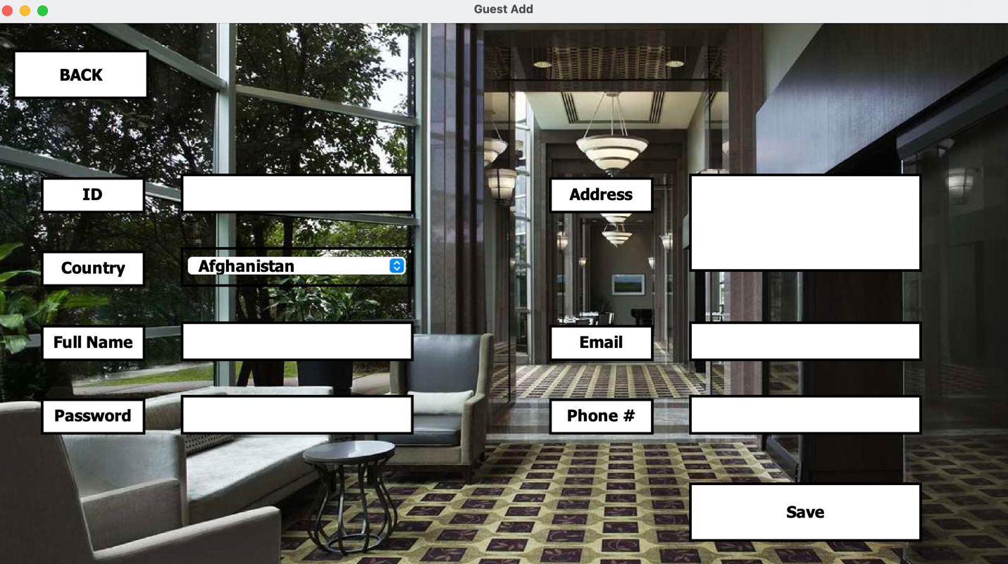  
Admin can Create a Jasper Report of All Guests By clicking the “Print” Button which will show a jasper report window and create a .pdf file of the report  
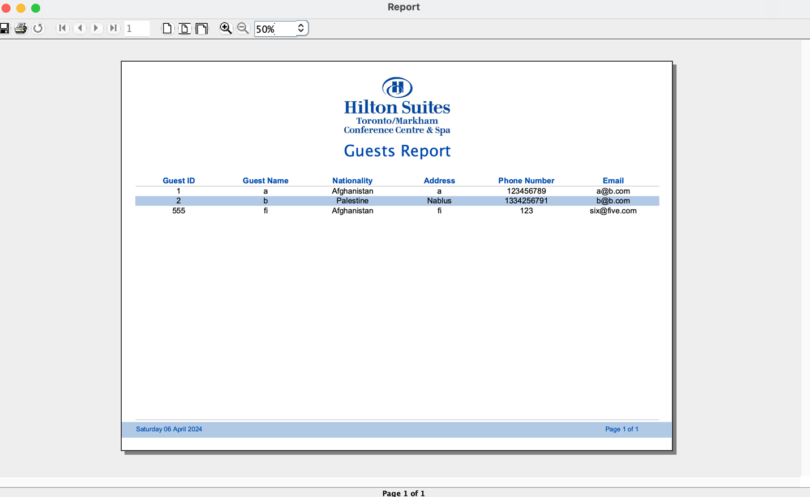*

* All Bookings Page

*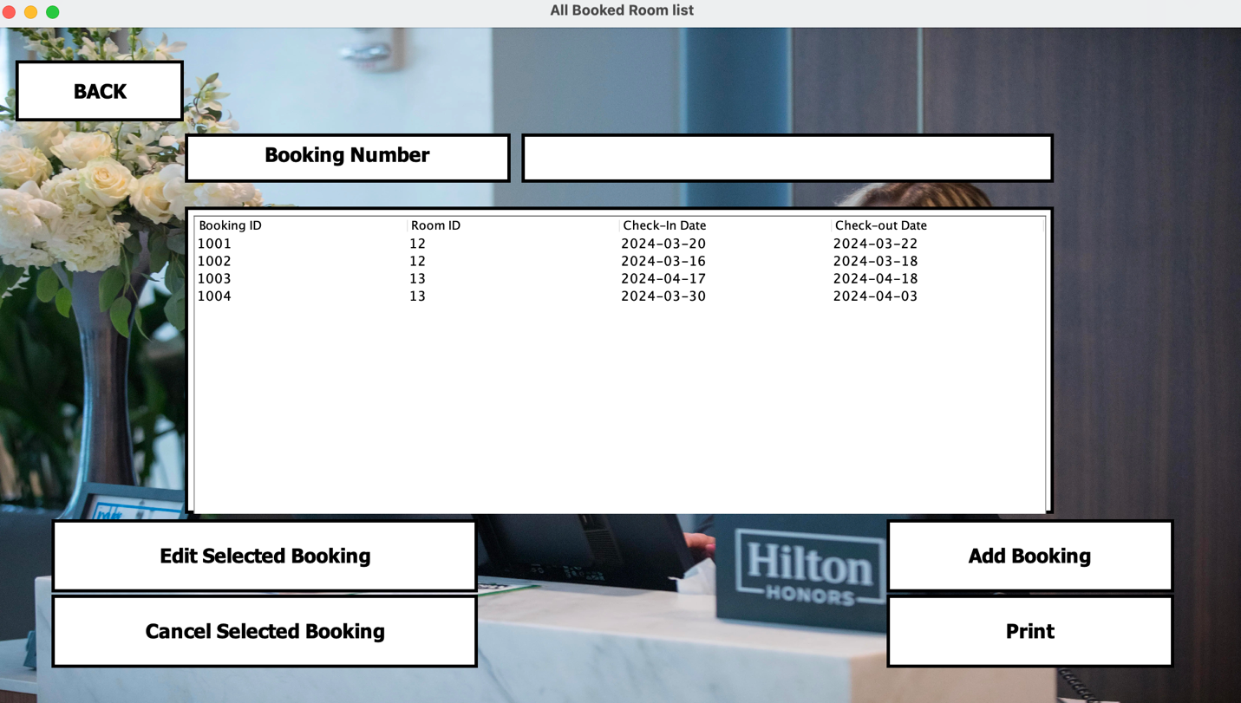  
In this page Admin can delete any Booking by entering the ID number of the booking they’d like to delete and clicking the “Cancel Selected Booking” button (As long as the check-out date hasn’t been reached). Admin can edit any booking by entering the Booking ID and clicking on “Edit Selected Booking” which will show the following page which is structured in a similar manner to the “Guest Book Room Page”  
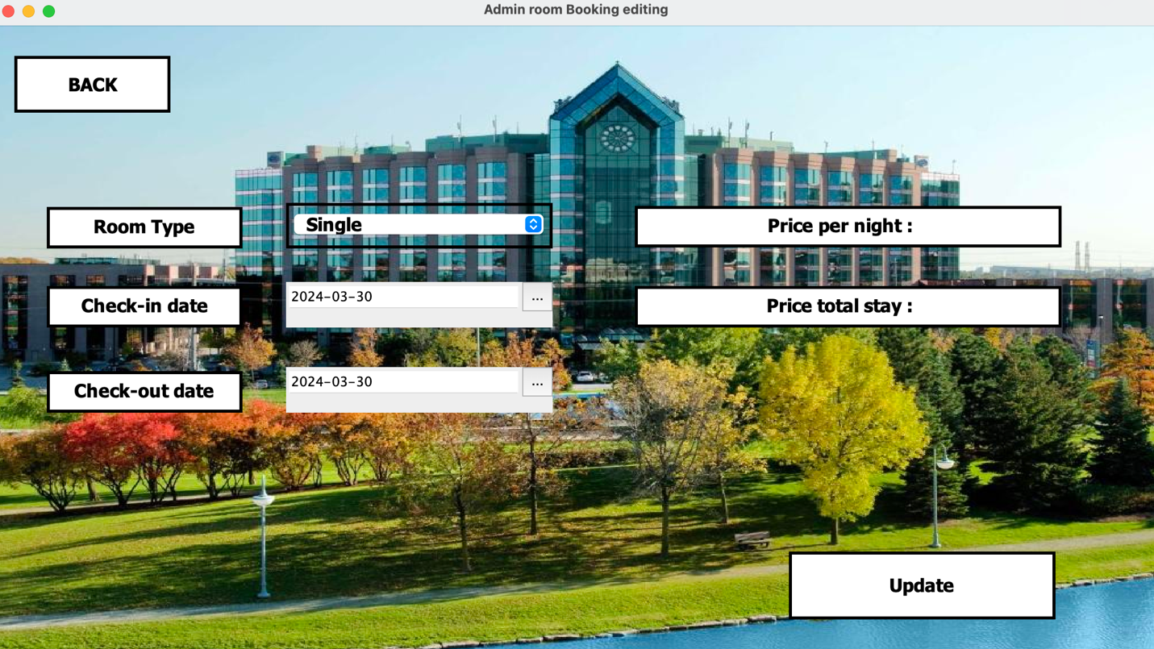  
Admin can Add a Booking by clicking the “Add Booking” button which will show the following page where admin can create a new booking and associate it with the guest they’d like by entering the Guest-ID of the guest they’d like to associate it with  
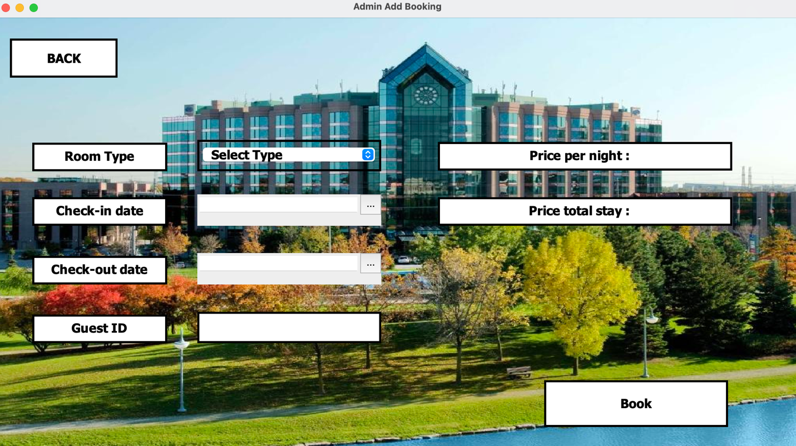  
Admin can Create a Jasper Report of All Bookings By clicking the “Print” Button which will show a jasper report window and create a .pdf file of the report  
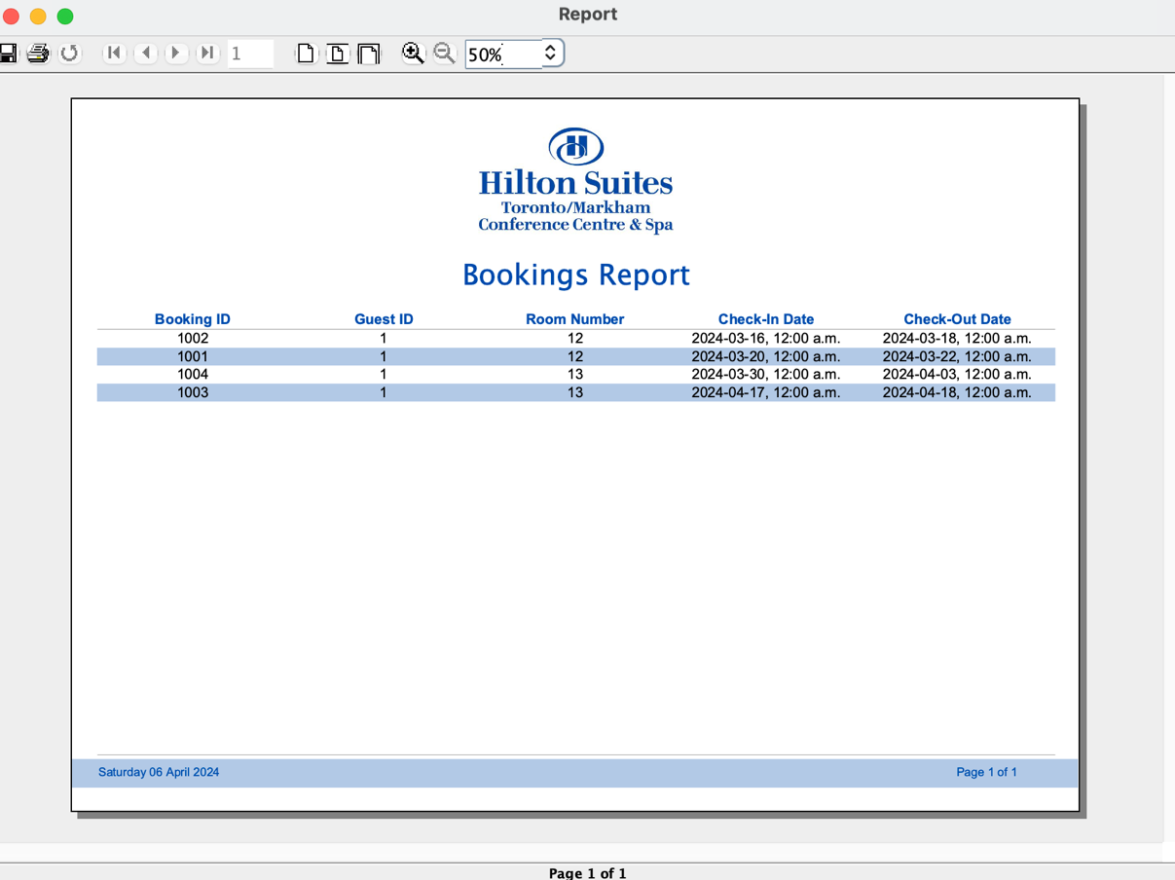*

* All Booked Room Services Page

*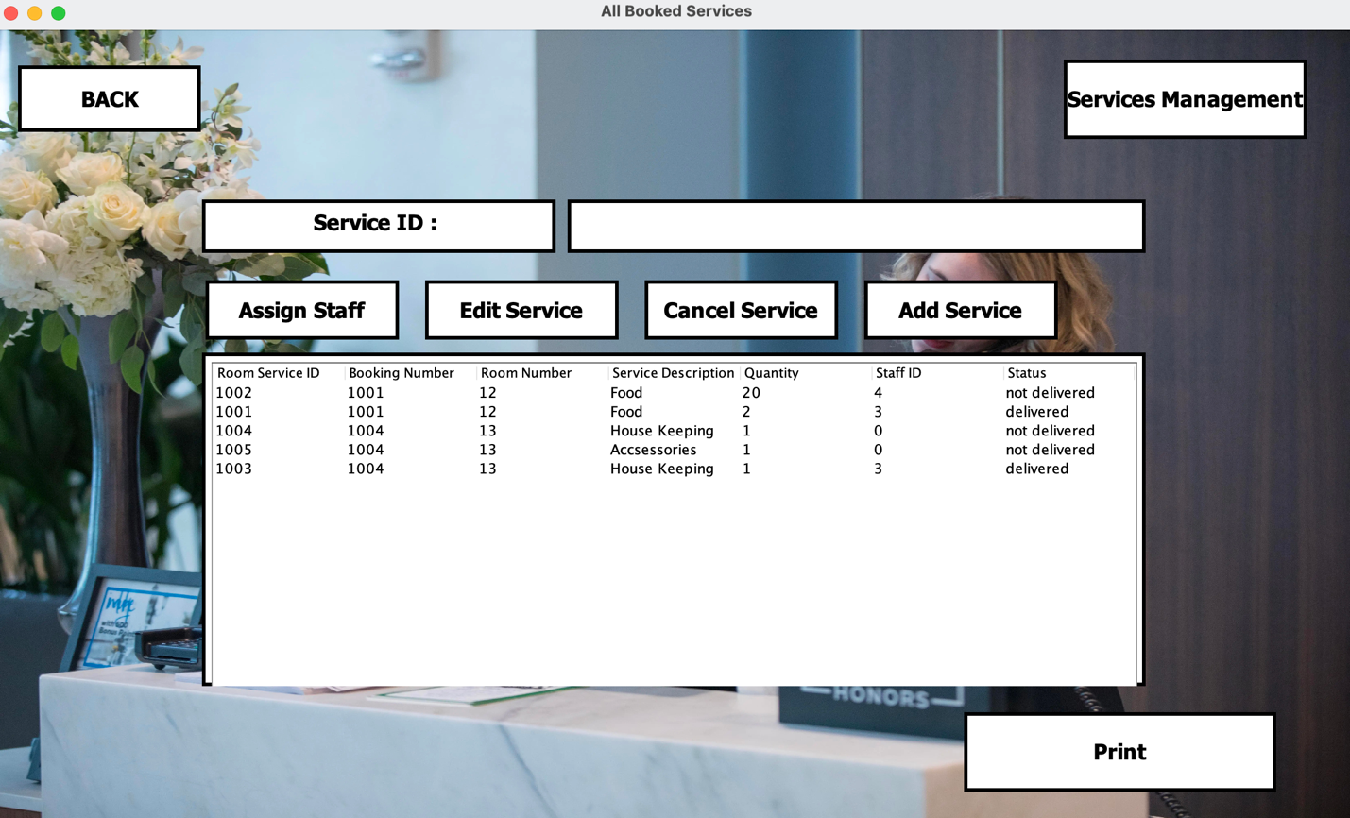  
In this page Admin can delete any Room Service by entering the ID number of the Room Service they’d like to delete and clicking the “Cancel Service” button. Admin can edit any Room Service by entering the Room Service ID and clicking on “Edit Service” which will show the following page which is structured in a similar manner to the “Guest Book Service Page”  
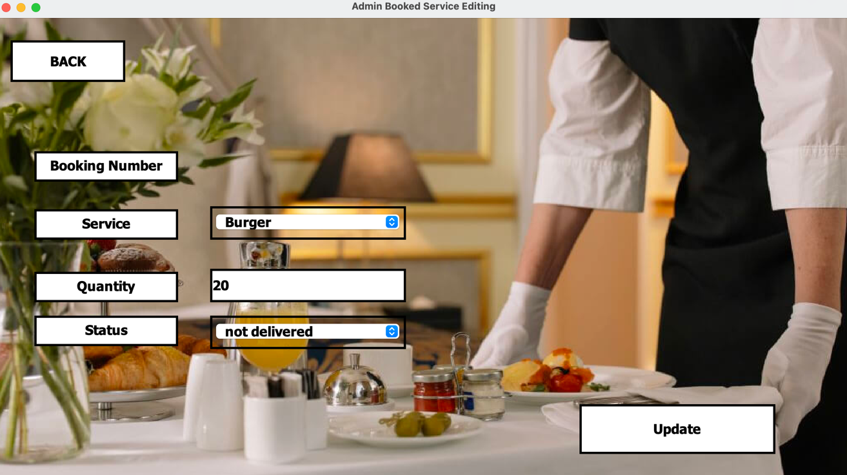  
Admin can Add a Room Service by clicking the “Add Service” button which will show the following page where admin can create a new Room Service and associate it with the booking they’d like by selecting the Booking ID of the Booking they’d like to associate it with from the drop-down list of all the bookings  
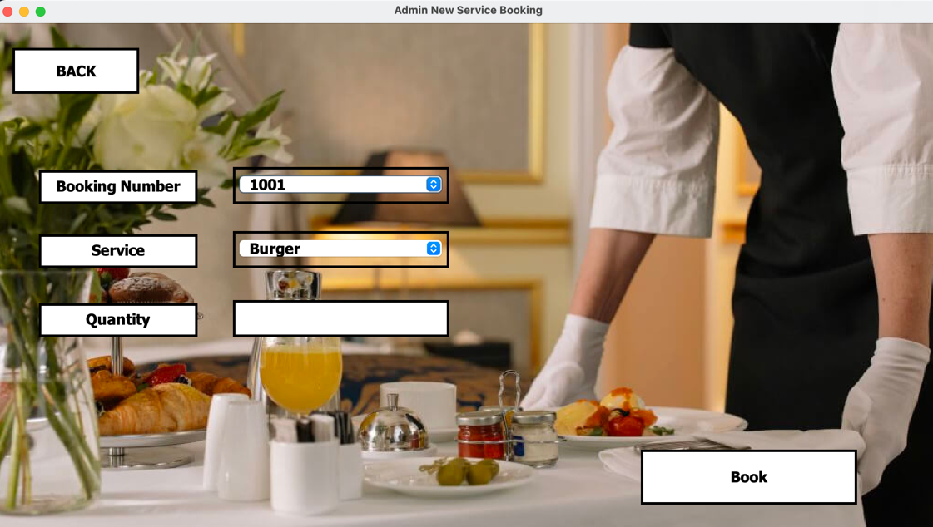  
Admin Can assign staff to Booking Services By entering the Booking Service ID they’d like to assign the staff to and clicking the “Assign Staff” button doing so will reveal the following window where the admin can select the staff they’d like to assign to the room service from the drop-down menu of Staff-ID’s   
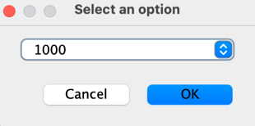  
Admin can Create a Jasper Report of All Room Services By clicking the “Print” Button which will show a jasper report window and create a .pdf file of the report  
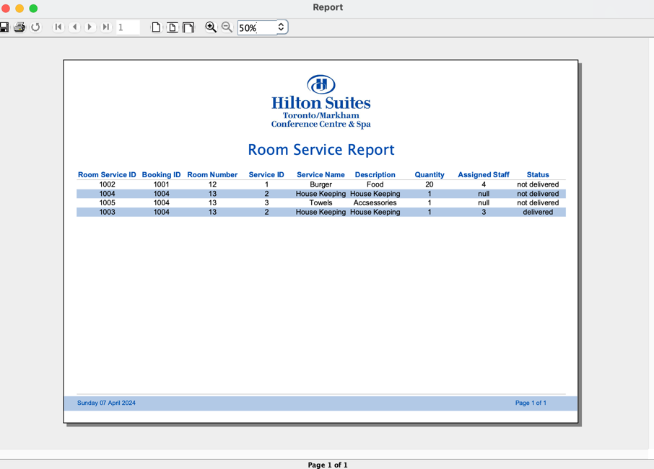  
Admin Can Also manage available services by clicking the “Service Management” button which will reveal the following page  
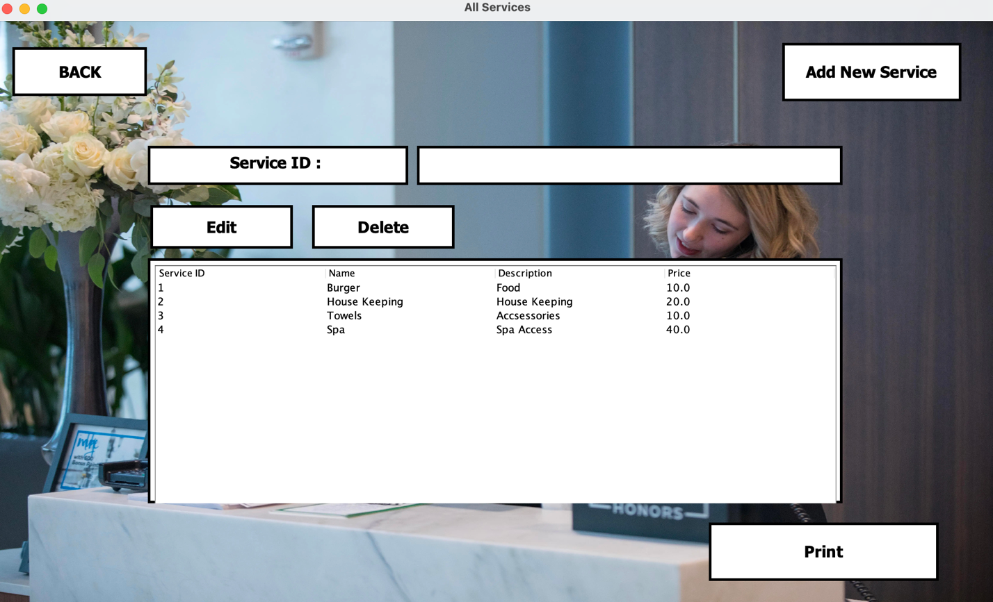  
in this page admin can delete any Service by entering the ID number of the Service they’d like to delete and clicking the “Delete” button. Admin can edit any Service by entering the Service ID and clicking on “Edit” which will show the following page  
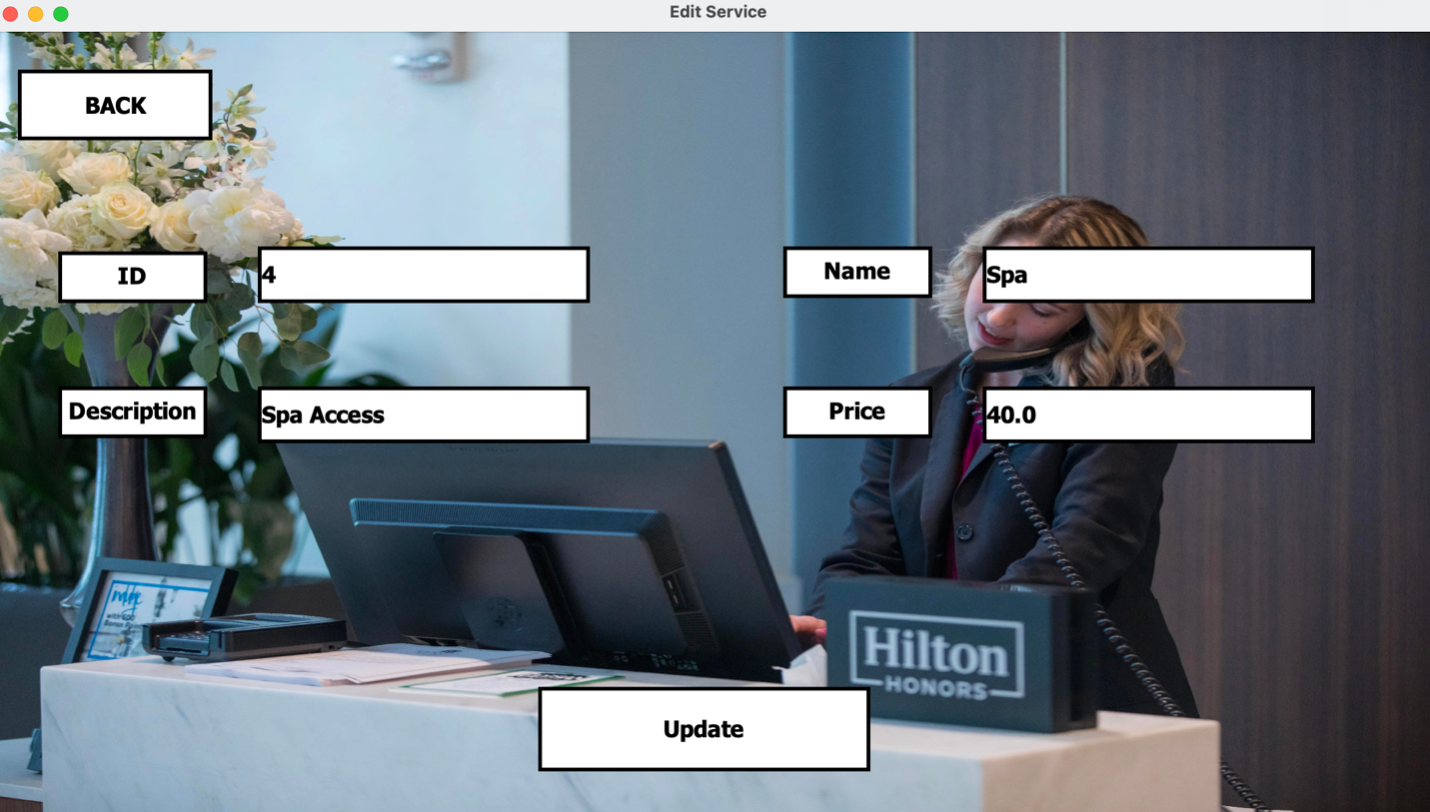*

*Admin can Add a Service by clicking the “Add New Service” button which will show the following page  
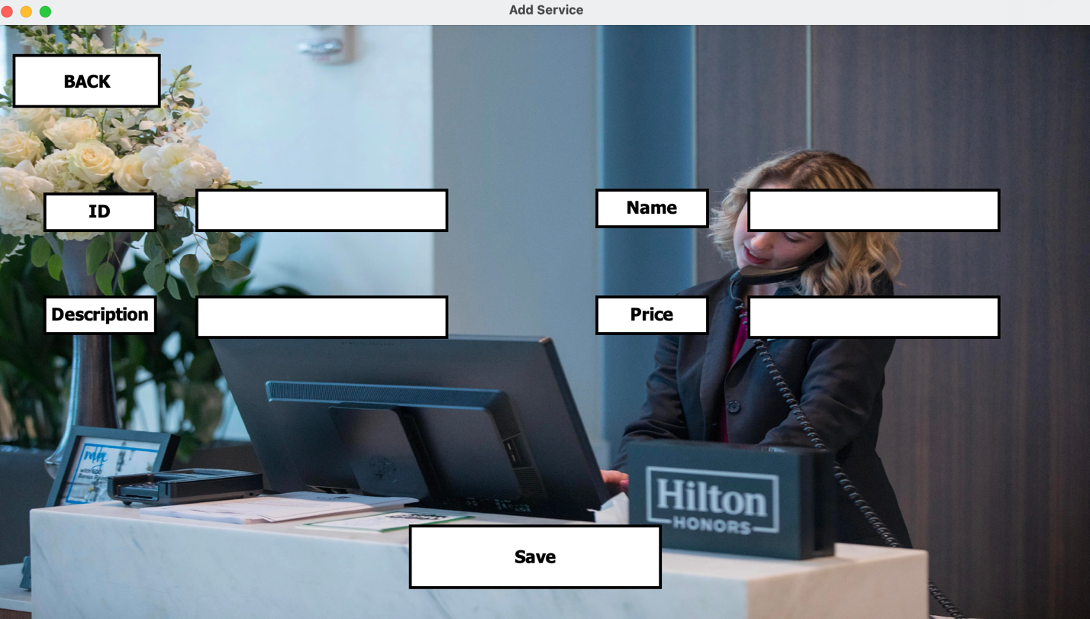  
Admin can Create a Jasper Report of All Services By clicking the “Print” Button which will show a jasper report window and create a .pdf file of the report  
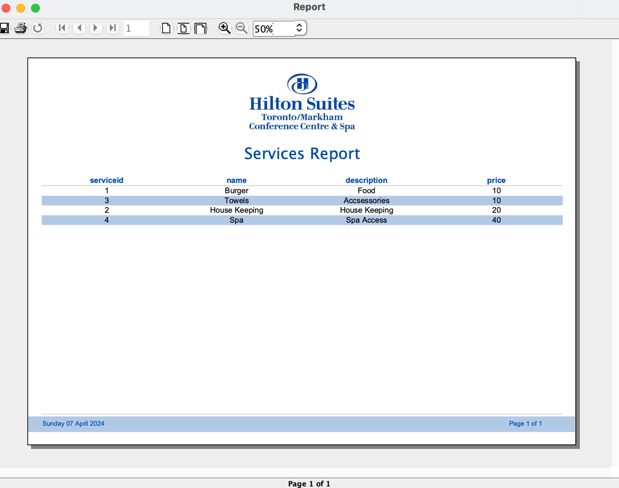*

* All Rooms Page

*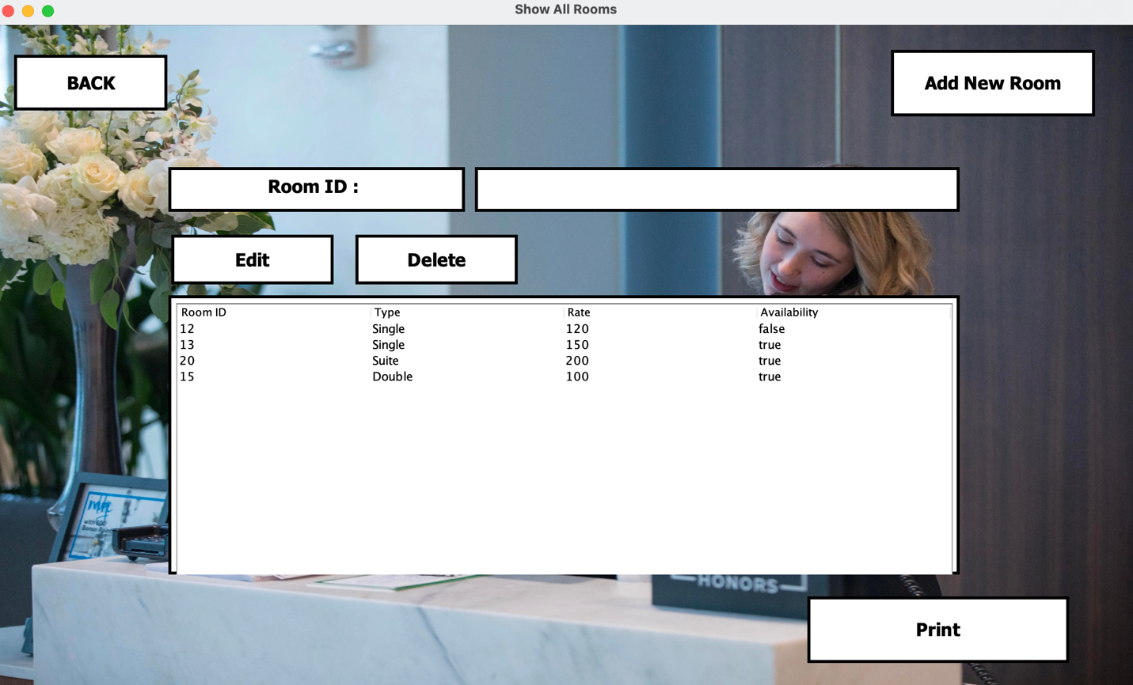  
In this page Admin can delete any Room by entering the ID number of the Room they’d like to delete and clicking the “Delete” button. Admin can edit any Room by entering the Room ID and clicking on “Edit” which will show the following page  
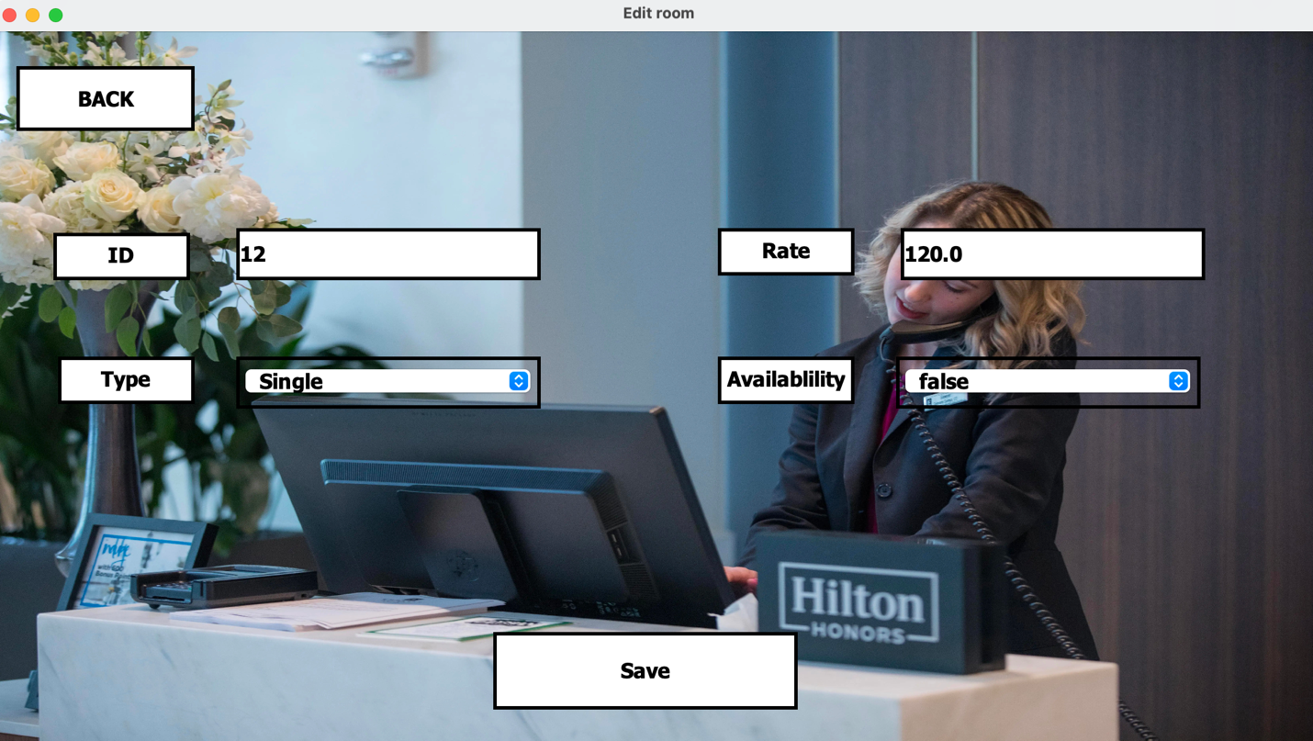*

*Admin can Add a Room by clicking the “Add New Room” button which will show the following page where admin can create a new Room  
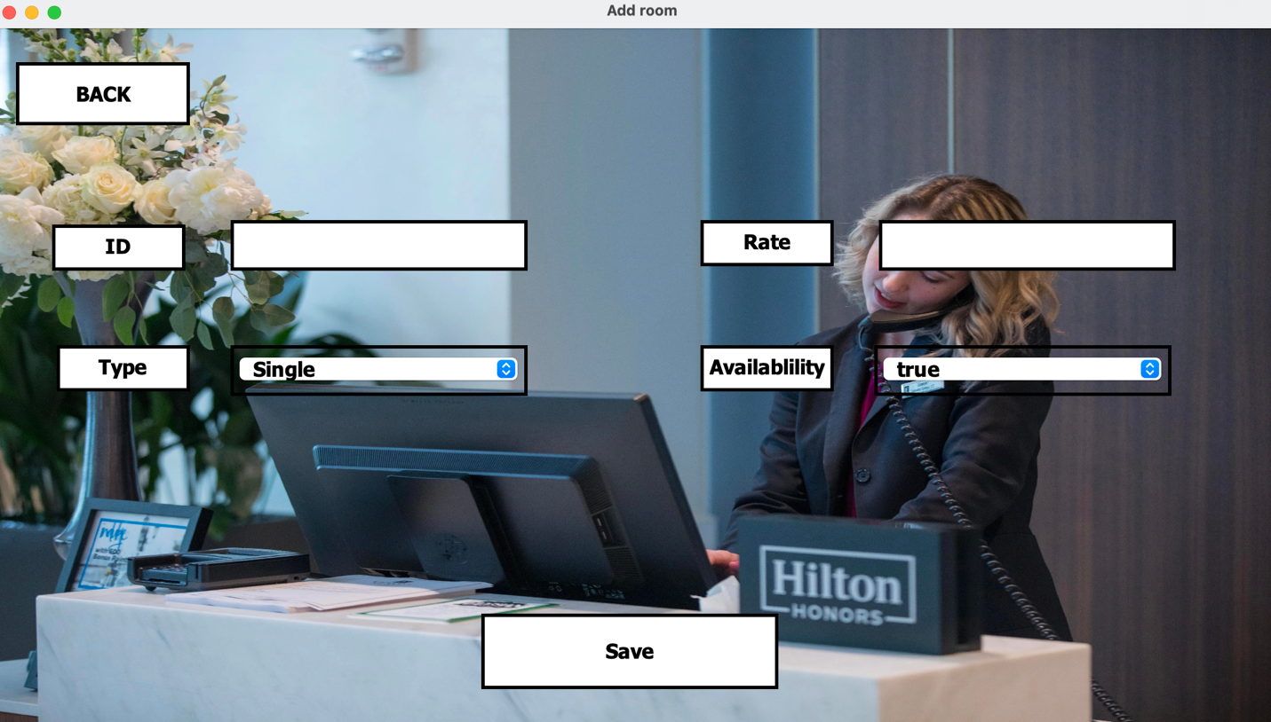  
Admin can Create a Jasper Report of All Rooms By clicking the “Print” Button which will show a jasper report window and create a .pdf file of the report  
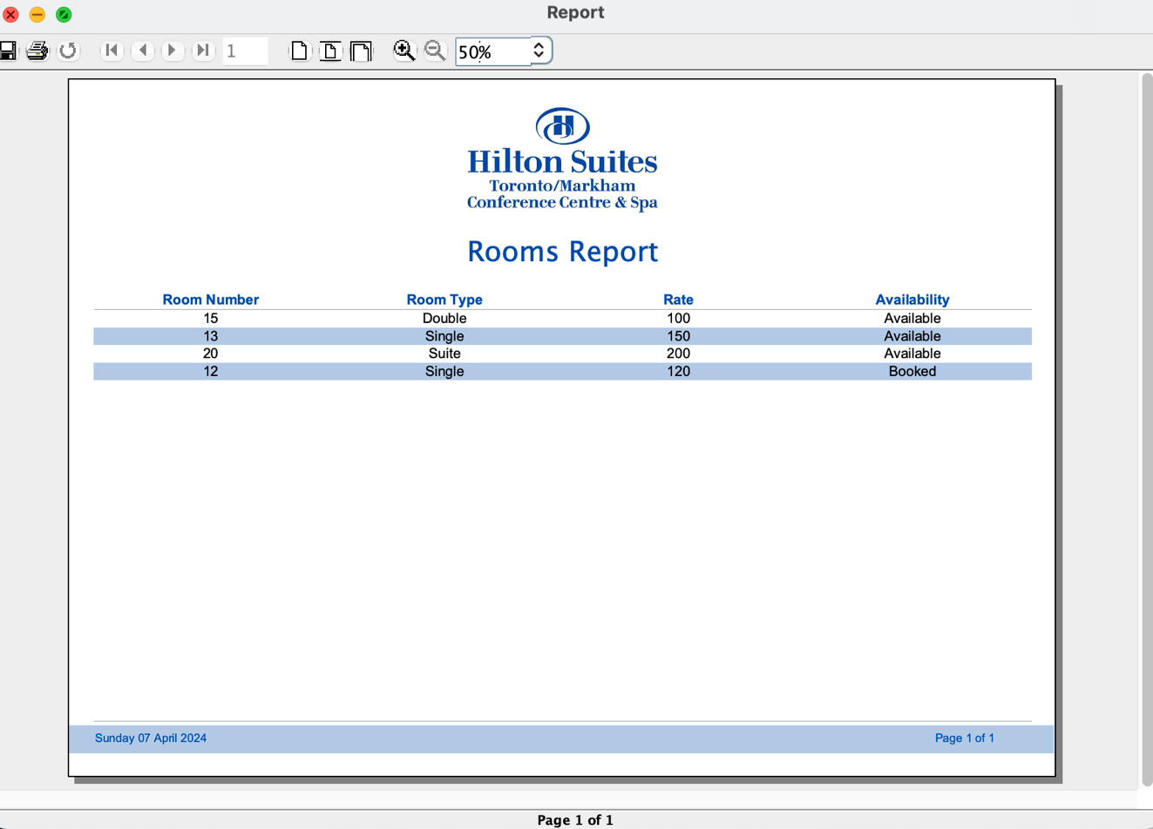*

# Jasper Reports

* Admin All Staff Report

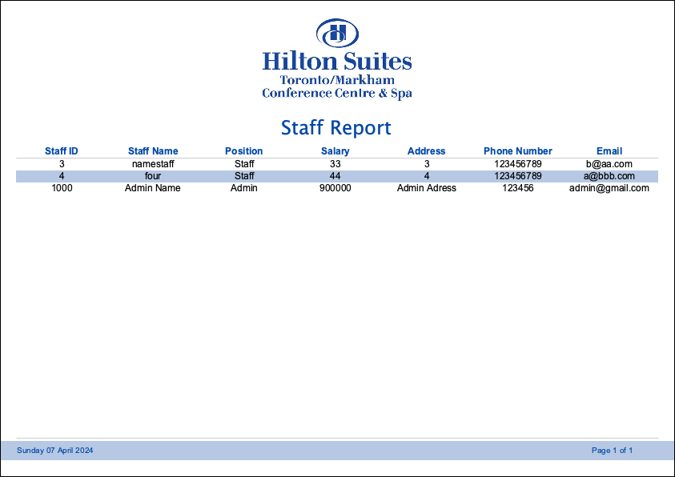

* Admin All Bookings Report

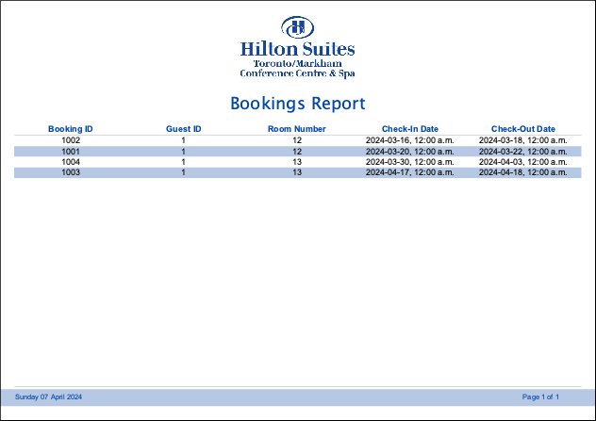

* Admin All Guests Report

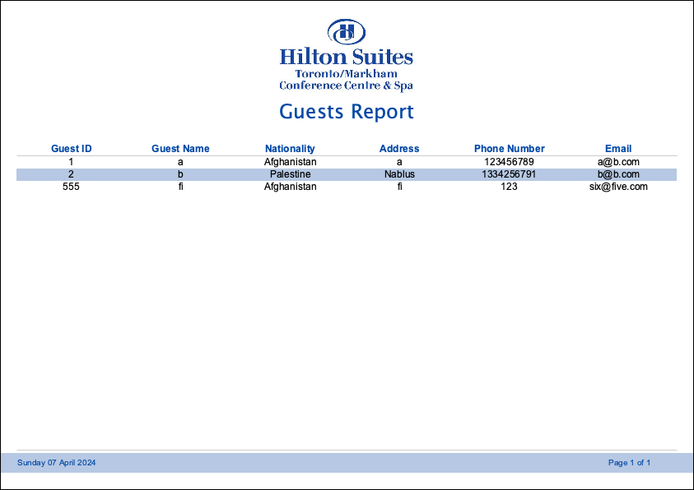

* Admin All Room Services Report

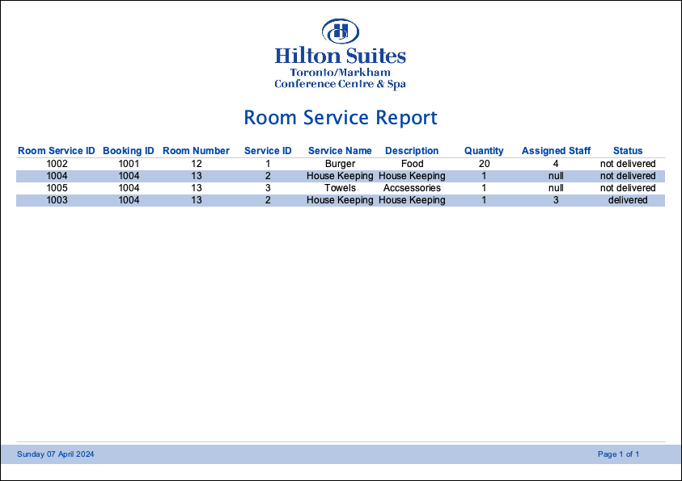

* Admin All Services Report

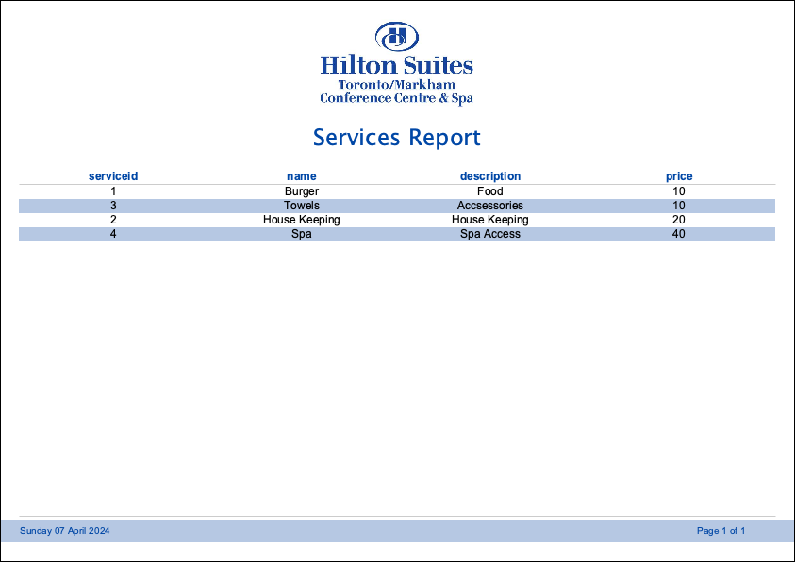

* Admin All Rooms Report

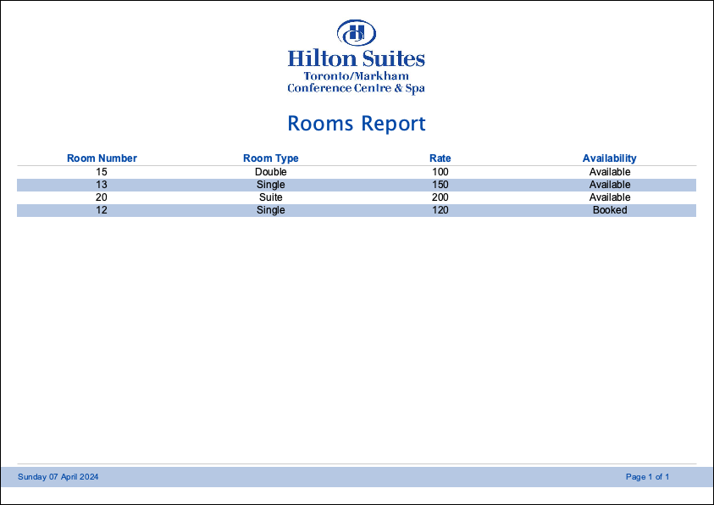

# Conclusion

*In conclusion,* *the development of this database system has the potential to greatly enhance the operational efficiency of the Toronto-Markham Hilton Hotel. By centralizing and organizing essential data using PostgreSQL, the system streamlines tasks such as room bookings, service requests, and staff management. This project empowers hotel employees and guests to quickly access and update information, using a Java GUI leading to improved guest experiences and optimized resource allocation. This project demonstrates the power and potential of using database technology and GUI-based software in driving positive change within the hospitality industry.*

# References

[*https://docs.oracle.com/en/java/javase/17/docs/api/index.html*](https://docs.oracle.com/en/java/javase/17/docs/api/index.html)

[*https://www.postgresql.org/docs/current/index.html*](https://www.postgresql.org/docs/current/index.html)

[*https://helpx.adobe.com/photoshop/user-guide.html*](https://helpx.adobe.com/photoshop/user-guide.html)